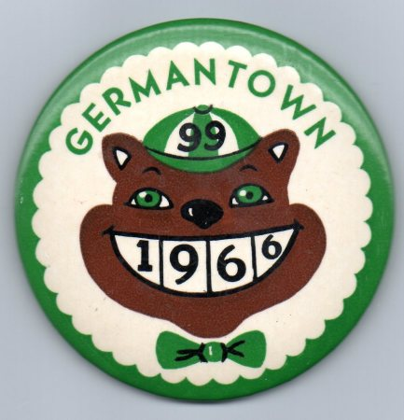

GERMANTOWN HIGH SCHOOL
CLASS OF 1966 – 50th CLASS REUNION

Dear Classmate:
Graduation day seems like yesterday. We are excited to revive old friendships and relive the glory days of high school. Your presence will make this a very special affair. We hope you plan to be there because the night would not be the same without you. Please be sure to fill out the reservation form below and mail it along with your payment . If you have any address/email/phone # on any of your classmates – please contact Susan Goldstein
Dyen (sweetsooze22@gmail.com; 215-968-9083) or forward this form to them.
PRICE: $80 per person before April 1st
$90 per person April 2nd to May 1st
$100 per person thereafter.
No payment after May 28th and no payment at the door
Checks or money orders only

Philmont Country Club website:
http://www.philmontcc.org
DATE: Friday, June 10, 2016
TIME: 7:00 p.m.—Reception & Cash Bar
8:00 p.m.— Full Buffet dinner, dessert bar
9:00 p.m. — Dancing and
Socializing
*********************************
PLACE: Philmont County Club
301 Tomlinson Road
Huntingdon Valley, Pa 19006
215-947-1271

NOTE: NO ONE WILL BE ADMITTED WITHOUT PAID ADMISSION!

ALL TICKETS WILL BE HELD AT THE DOOR

****************************  DETACH HERE *************************
PLEASE MAKE YOUR CHECK OR MONEY ORDER PAYABLE TO:GHS 1966 Class Reunion Committee AND MAIL TO: Susan Goldstein Dyen, Treasurer, 410 Parkview Way, Newtown, PA 18940
Please reserve ______ tickets
@ $______each.

Total enclosed: $_______

Enclosed is a check/money order
payable to GHS 1966 Class Reunion Committee

******NO REFUNDS*******

GHS 1966 Class Reunion Reservation Slip
Rec’d_________Chk#______
(For reunion purposes only)

___________________________________________________
Last Name Maiden Name First
___________________________________________________
Address City State Zip
___________________________________________________
Phone E-mail address
___________________________________________________
Spouse/Guest Name ___Check here if a GHS 1966 graduate.

