**RE: DURBAN HIGH SCHOOL (1966) OLD BOYS ASSOCIATION**

Dear Durban High School (1966) Old Boys Association

***A donation to Childline South Africa is an investment in the future, an investment in the children and families of South Africa.***

***Like all NGO’s we have a wish list:***

*1*

*Childline Sa presently requires funds to own their own home, the past 10 years Childline SA has been paying Rent for premises and been in 3 different locations, we are presently (since 2013) at 24 Stephen Dlamini Road (old Essenwood Road) not far from DHS. We require funds/donations in order that we can be in a permanent home, funders only provide funds for Projects and therefore unable to accumulate surplus funds.*

*2*

*Childline has a 24 hour crisisline call centre, thanks to Telkom, all calls made to this number 08000 55 555 from Telkom lines, MTN and Vodacom are free (Cell C do not sponsor free calls).*

*Whenever a caller is in RSA that call is directed to the nearest crisisline centre.*

*Our major donor for the Crisisline Centre (there are 9 centres/provincial offices in South Africa) can no longer provide donations due to a ruling by the NLDTF.*

*We therefore urgently require additional donations to maintain our core service which is the Crisisline - receives over 800 000 calls per annum.*

*90% of such calls are from the previously disadvantaged.*

*Childline South Africa is a member of Child Helpline International which has over 250 offices situated world-wide. Our National Executive Officer, Dumisile Nala is the Regional Representative for Africa at Child Helpline International.*

*Interestingly, Dumisile’s son matriculated at DHS last year.*

*Read more about Childline in this profile our banking details can be found at the end of this report.*

***Visit our website:*** [www.childlinesa.org.za](http://www.childlinesa.org.za)

***Facebook :*** <https://www.facebook.com/ChildlineSA/>

Childline South Africa is the national office of all Childline provincial offices in South Africa. Each province in South Africa has a provincial Childline office to which calls to the toll free telephone line are directed and from which Childline conducts a variety of child protection services. The national office provides support, capacity building, and training to all the provincial offices as well as running the online counselling service to the children of South Africa.

Childline South Africa also has a strong advocacy role and lobbies actively with key decision makers from all spheres of government for an improved and more effective child protection system. A key achievement has been the contribution made to the establishment of a progressive legal framework and policies that protect children from all forms of abuse and ensure access to social services.

Childline South Africa seeks to provide a better life free of abuse, neglect and exploitation for all the children of South Africa. As Childline South Africa we believe what we do for the children today will ultimately affect who they become tomorrow.

On a monthly basis Childline trains health and social service professionals on child related issues, including child law training.

Over 90% of our beneficiaries are previously disadvantaged children and communities.

**Some of the benefits for supporting Childline South Africa with this sponsorship could include:**

* Acknowledgement of the donation and support received through the use of local media and advertising and inclusion on the Childline SA website and AGM Report
* Increased visibility of the support received and the relationship developed between Childline South Africa and Durban High School
* Tax certificate and thank you letters

***“To know that even one life has breathed easier because you have lived this is to have succeeded…” Ralph. W. Emerson***

**CHILDLINE SOUTH AFRICA- ORGANISATION INFORMATION**

Name of Organisation : Childline South Africa

Physical Address : 24 Stephen Dlamini Road

Berea, Durban 4001

Postal Address : P.O. Box 51418

Musgrave

4062

Contact Person : Dumisile Nala

Position : National Executive Officer

Contact Details : 031 201 2059/ 082 8683000

Email : [dumisile@childlinesa.org.za](mailto:dumisile@childlinesa.org.za)

Contact Person : Philippe Bouffé

Position : Finance Manager

Email : [[finance@childlinesa.org.za](mailto:finance@childlinesa.org.za)](mailto:finance@childlinesa.org.za)

Contact Details : 031 201 2059/ 083 7878188

Website : [www.childlinesa.org.za](http://www.childlinesa.org.za)

Twitter : @childlinesa

Facebook : Childline SA

MXit : Safety Counselling- Childline

Legal Status : Non-Governmental, Non-Profit

Organisation

Registration Number : 035-472NPO

Section 18A/ Tax Exemption : PBO 930019371

Vat Number : 4960232025

# CHILDLINE SOUTH AFRICA

**Vision**

Childline is an effective non-profit organization that works collectively to protect children from all forms of violence and to create a culture of children’s rights in South Africa.

**Our Mission – We are committed to:**

* Supporting and capacitating the Provincial Affiliates where needed
* Developing appropriate social services including a 24 hour toll free helpline and supportive therapeutic social services for children who have been victims of violence and their families
* Education and awareness raising programmes facilitating the prevention of violence against children
* Networking to establish strategic alliances with the aim of advocating for policy changes that will facilitate good management practices for abused children
* Research into violence against children within the South African context
* On-going training and development of staff members, volunteers and networking partners

**Goal:** to uphold the rights of children in South Africa and respond appropriate when children’s rights are violated.

**Brief organisational history in SA**

The Childline movement in South Africa was initiated in 1986 with the establishment of Childline KwaZulu-Natal after Paediatric staff at Addington Hospital in KwaZulu-Natal noted with concern the number of children attending clinics or hospitalised with non-accidental injury. Children disclosed that they had no opportunity to report abuse and identified the need for a call centre.

In 1988 Childlines Gauteng, Eastern Cape, and Western Cape were established, followed in subsequent years by Childlines Free State, Northwest, Mpumalanga, Limpopo and Northern Cape.

In 2003 it became clear to the then existing provincial offices that a coordinating and representative structure was essential on a national level and therefore, Childline SA was established in August 2003.

The National Childline Office coordinates and capacitates the nine provincial offices, by supporting them in their service delivery.

[Banner 14](http://childlinesa.org.za/index.php/gallery/2-online-banners/detail/102-new-picture-17?tmpl=component)

**Our Programmes:**

**1. Crisis Line**

The toll-free crisis telephone counselling line deals with hundreds of queries from children and adults. The line, which provides an invaluable educative service, receives calls relating to a wide variety of issues and problems including:

* Abuse (physical, emotional, sexual); Child Pornography;
* Abuse at school by educators; Abandonment;
* HIV/AIDS; Relationship problems (peers, parents, teachers);
* Sexual problems and pregnancy; Depression and attempted suicide;
* Neglect; Financial problems; Learning and educational problems;
* Bullying; Harassment; Homeless children; Begging;
* Divorce, custody and access; Sibling issues; Loneliness; Test calls.

The Childline Toll free number receives approximately 60000 to 90000 calls per month across all the provinces.

We may be contacted on 08 000 55 55 5, 24 hours, seven days a week.

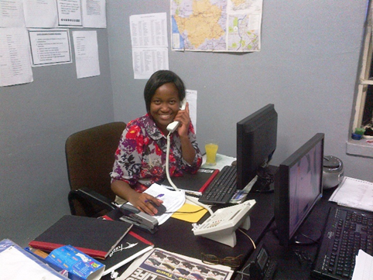

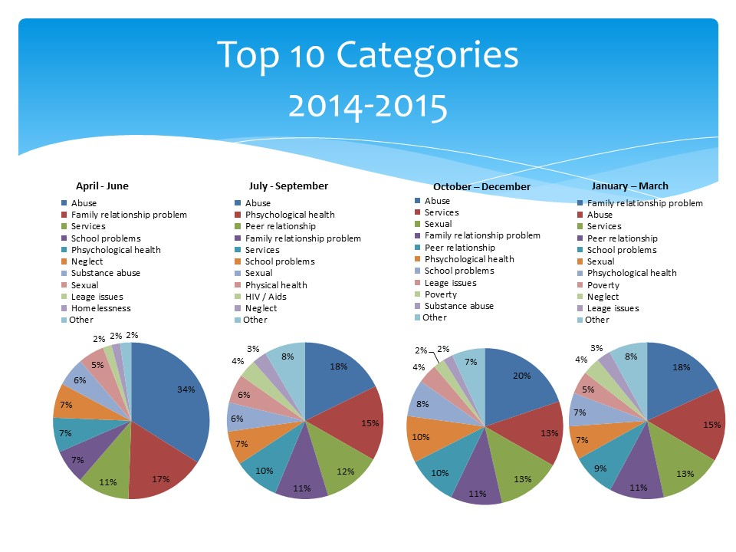

**Success Story from the crisisline**

The concerned aunt of a 4 year old boy and a 6 year old boy phoned the crisis line. Both her brother and his wife were using drugs and they were having sexual intercourse in front of the children while the children were also exposed to pornographic videos. The children also stopped attending school and crèche. They showed signs of having been sexually abused. The caller was concerned that the parents might sell the children or force them into child prostitution as they were desperate for money to buy drugs. **Outcome:** Both parents tested positive for various drugs and the children disclosed about their horrendous situation. A statutory social worker was called in and the children were removed and placed in foster care with relatives in another province. The children are flourishing in their new environment. 

**2. Prevention & Education**

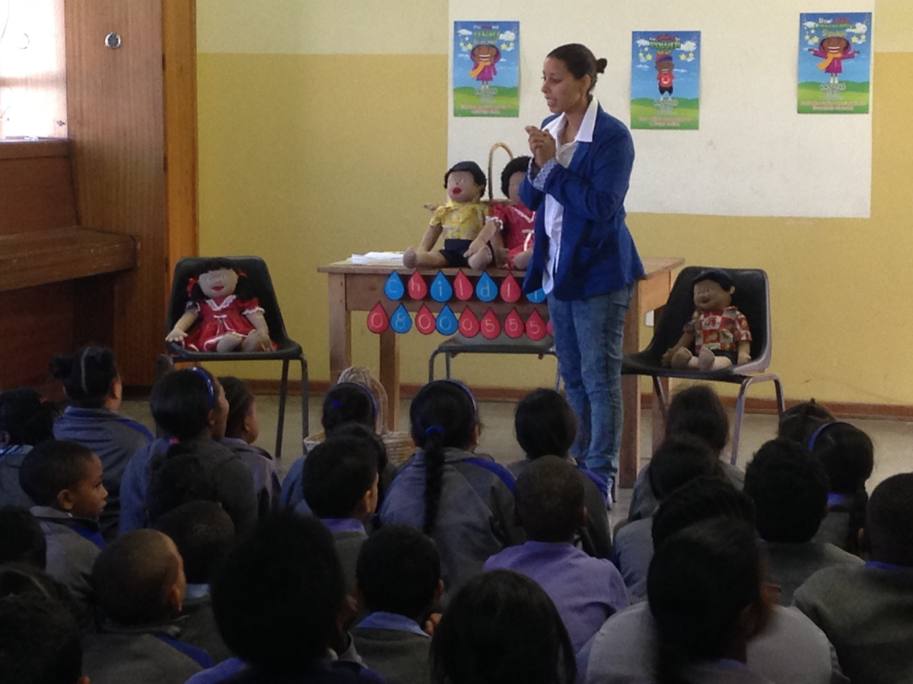

Our Prevention and Early Intervention programmes include interactive talks, presentations and workshops for children and adults in schools and communities sharing information and empowering educators, learners, parents with children’s rights and related issues. These activities are facilitated in a number of ways including class-by-class, age-appropriate talks to children in primary and high schools. The programmes are also very participatory in nature.

Communities, children and young people are given pamphlets and resources at the end of the programmes/sessions.

The following are some of the topics covered in the programmes:

* + Signs and symptoms of child abuse, dealing with disclosures, and reporting procedures
  + Types of abuse
  + Children’s rights
  + Parenting skills including positive discipline and understanding your child’s behaviour
  + Parental rights and responsibilities
  + Bullying and cyber bullying
  + Teenage sexuality, including sexual harassment as a sexual violation, teenage pregnancy, body image
  + The pros and cons of social media
  + Peer Support
  + Children’s legislation
  + Ad hoc requests relating to children’s issues
  + Who to go to for assistance when they need help
  + Awareness of Childline Services

Community Development Programme includes: child protection interventions, child protection forums; household economic strengthening; education support; and HIV education, counselling and testing.

The objectives of the programmes are extensive including:

* To improve the well-being of Orphans and vulnerable children and youth (OVCY) and their families through comprehensive and coordinated evidence-based interventions;
* To strengthen the capacity of families and communities in caring for OVCY in their area of operations;
* To develop clear comprehensive referral system with stakeholders and in-house programmes to ensure effective service delivery to OVCY.
* Create awareness and knowledge for better care and protection of children and young people

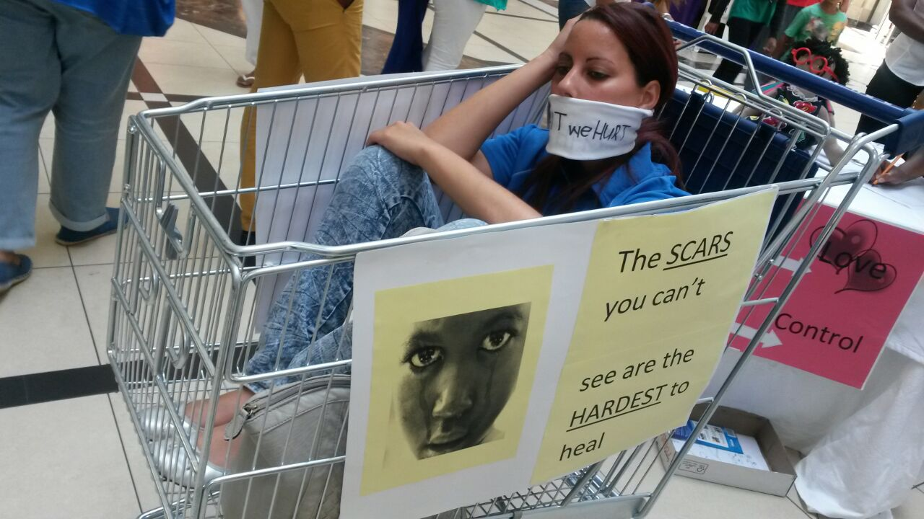

**Outreach Success Story**

A learner was abducted at a Phoenix school in the northern part of KwaZulu Natal. The Crisisline and Therapeutic Manager assisted with debriefing of the Educators and the social workers with the learners. During the weekend the said child’s decomposed body was found in a manhole. Learners, Educators, Parents and community members as a whole were distraught. The outreach facilitators conducted the necessary programmes as part of their containment strategy. The support from the team assisted the school and community to cope appropriately.

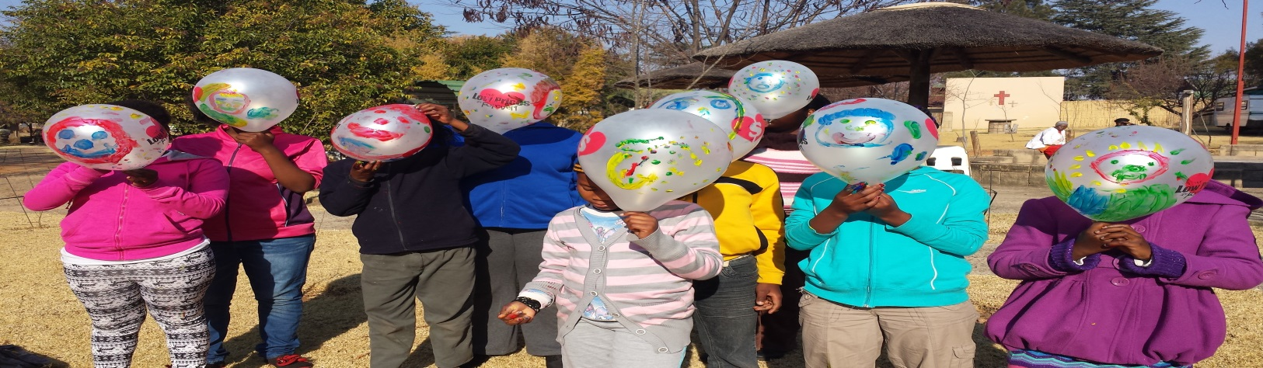

**Challenges**

Funding for outreach programmes is a great need in the provinces in order to sustain the programme. Additional funding would ensure that many more children, educators, parents and community members are reached through the programme.

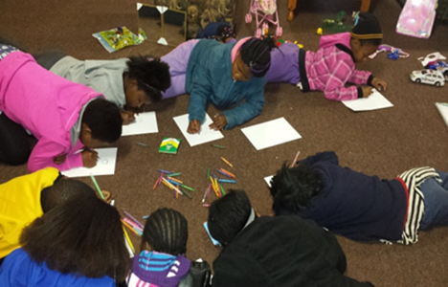

**3. Training of Volunteers & social service professionals**

Childline trains volunteers to assist in providing services, while under the supervision, mentoring and monitoring of professional staff. Volunteers provide a large component of the on-line counselling done by Childline. Staff and volunteers receive training on HIV/AIDS and counselling, child law and child protection. Training is also on a monthly basis training health, social service professionals and the South African Police Service. Currently Childline South Africa is running the **Thogomelo** Training providing psychosocial support and skills development for community caregivers.

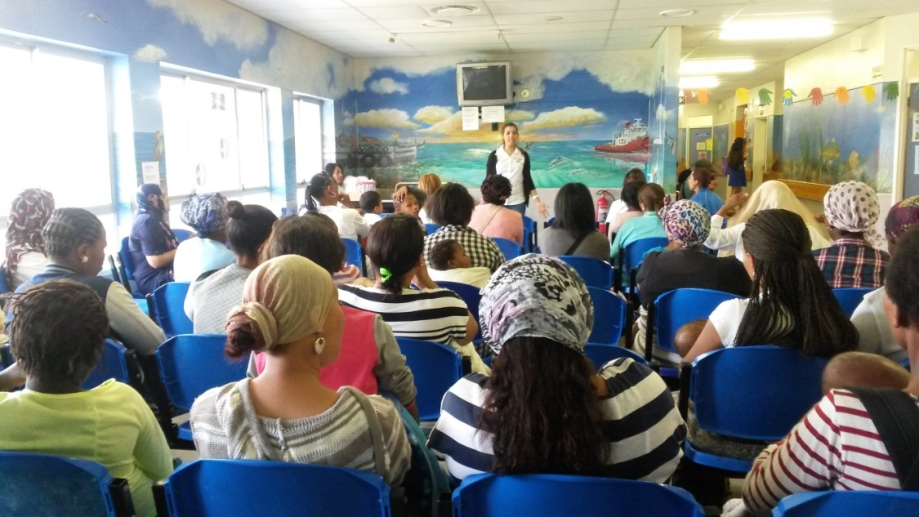

**4. Treatment services to abused children and their families**

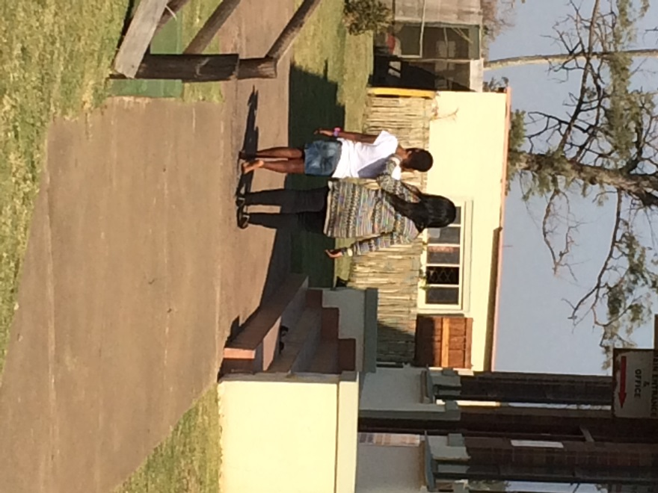This includes dealing with families of children who are HIV/AIDS infected as a result of sexual abuse. Therapy focuses on children developing patterns and practices of responsible sexual behaviour. The organisation is currently running a **Residential Therapeutic** **Programme** which seeks to provide therapeutic and support services to rural victims of rape and sexual assault and their care-givers. Caregivers are often overwhelmed with many different feelings when they discover the abuse. They may feel: rage, guilt, sadness, depression, fear, confusion and/or betrayal. If they become involved in the legal process, there is even more stress and anxiety. These feelings may leave caregivers feeling very protective towards their child, or they may be angry and blame the child for what happened. Parents and caregivers need support and guidance in order to help their child heal and to repair any hurts that may have come between them and their child.

**Care of the caregiver is care of the child.** A treatment programme is also being run for children who are sexually offending or exhibiting sexually inappropriate behavior.

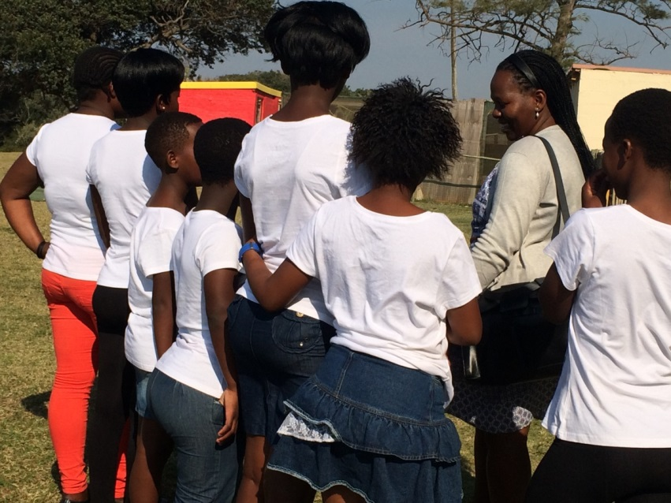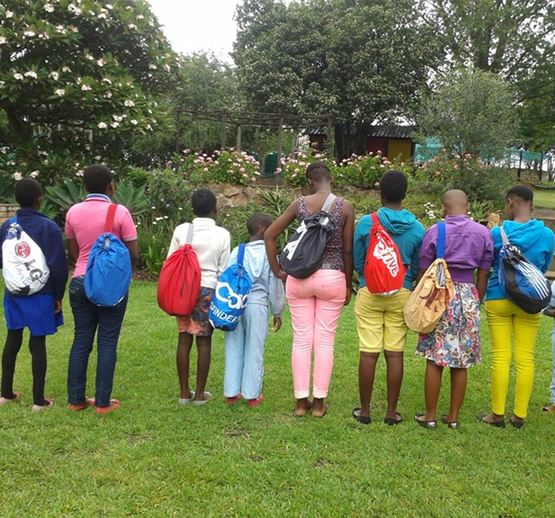

**5. Online Counselling Service**

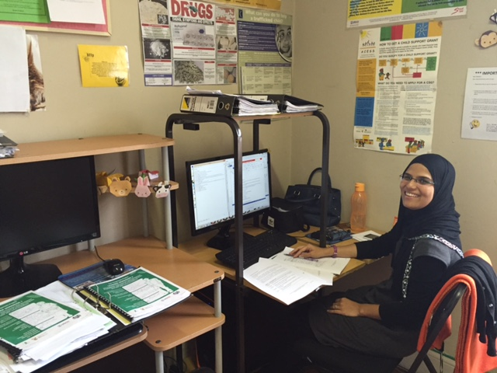In the light of the ever growing use and popularity of the internet, and an increase in popularity of online communication, particularly by adolescents, Childline South Africa is keeping up with the times, and meeting young South Africans where they are “online”. Childline South Africa therefore began a pilot project of online counselling in May 2009 in partnership with MXit as the online service provider. Online counselling as a service offered to youth in particular, is already in place and successful in several other countries.

Online Counselling and assistance is offered nationally Monday – Saturday, from 2pm – 6pm. The Online counselling service is available to South African youth under the age of 21 years, who are registered on MXit**,** as well as to adults with concerns about children. Online counsellors are Durban based and operate from the Childline South Africa National office. The service works closely with all Childline provincial offices, to which children and youth requiring face to face services are referred.

The aim of the online counseling service at Childline National Office is to explore and utilize all forms of electronic communication open to children, youth and adults with concerns about children in order:

* to provide counseling and information services and
* contribute to the overall well-being of children, youth and caregivers of children,
* ensure the inclusion of children and youth with disabilities, particularly the hearing impaired.

.Our statistics show that we predominantly chat to users between the ages of 19-21 years and they are most likely female as depicted below.

In the stated period, we chatted to a total of 1218 users.



|  |  |  |
| --- | --- | --- |
| |  | | --- | | **32%** | | | **12%** |

**Our Provincial Offices:**





**Areas of Childline SA expertise include**:

The National Office:

* The provision of **coordinating and capacitating** structure and support for all provincial affiliates and their partners in their service to children and their families. This is inclusive of national data collection and reporting;
* **Networking and collaboration** with other organizations and professionals, acting as a referral source to the Provincial Childline Offices for those who seek guidance in dealing with cases of actual or suspected child abuse;
* The contribution, whether by **research**, clinical practice or otherwise, to the body of empirical knowledge on issues relating to prevention and treatment in the field of child abuse, and to provide support and coordination where appropriate, to research in the provincial offices;
* **advocating and propagating** children’s rights by participating in policy development and implementation in collaboration with the National Government, Government institutions, Provincial and local governments and other organizations operating in the fields of interest of Childline;
* **Establishing policies, procedures, and organizational structures** that will support service provision both in the national and the provincial offices;
* **Training** in law and policy relating to children’s rights and appropriate inter-sector responses to VAC, including psycho-social care;
* The development of **advocacy materials** to encourage the appropriate use of child protection services;
* The provision of **on-line counselling**
* The provision of PSS and therapy services to rural children who have experienced violence or are exhibiting sexually violence and inappropriate sexual behaviour via participation in residential therapy programmes together with their caregivers.

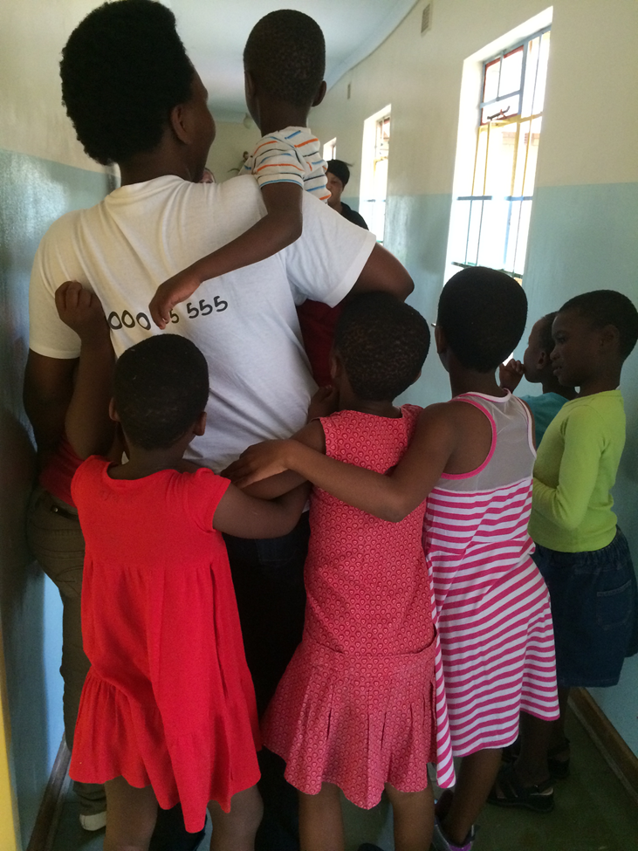

|  |  |
| --- | --- |
| **BANKING DETAILS** |  |
| Bank | NEDBANK |
| Branch | SMITH STREET DURBAN |
| Branch Number | 130526 |
| Account Number | 1305978609 |
| Name of Account | CHILDLINE SOUTH AFRICA |
| Swift Code | NEDSZAJJ |