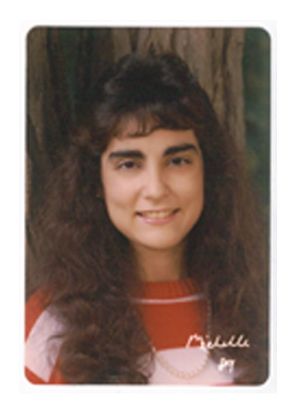 | Remembering Michelle  Michelle Lynn (Rahimi Keshari) Kubischke  Sylvania Northview High School  Class of 1989  As a candle lights the darkness, Michelle illuminated our world. She forever changed all of us through her passion for life, love and learning. Devoted mother, loving wife, daughter, sister, aunt, niece, cousin and friend, her generous spirit enhanced our lives and touched our hearts like no other. A dedicated teacher, she found joy in contributing to children’s lives, igniting a life-long love of reading and learning in so many. Proficient at all she endeavored; Michelle approached life with a quick wit and a warm smile that will live on in our hearts forever. The benefit she left the world is immeasurable, as is its loss
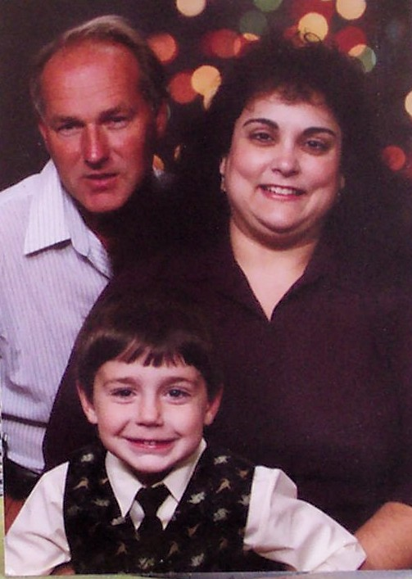  Robert, Michelle and Michael Kubischke  Last Family Christmas Portrait – November 2006 | Michelle passed away in Columbia, South Carolina, on Sunday, November 4, 2007, as a result of complications sustained with the birth of her second child. Her friends and family are still reeling from this devastating loss. Anyone wishing to share memories of Michelle may do so by visiting the guest book website indicated below or you can contact her family through her sister, Cindy Keshari Steele (class of ’81.) [Cindy’s contact information is also below.]  After graduation from Northview, Michelle attended Eastern Michigan University in Ypsilanti from 1989-1993, where she earned a Bachelor’s in Education. Having always loved the south and being a Civil War buff, she decided to attended graduate school at the University of South Carolina in Columbia and moved there in early 1994. (Those of you who remember your Civil War history will recall that South Carolina is where it all started, specifically at Fort Sumter.) Later that year, she met Robert David Kubischke, a local gentleman from nearby Swansea. Michelle received a Master’s in Education from USC in 1995. She then began teaching Fourth Grade at Edisto Elementary School in Orangeburg, South Carolina. On July 26, 1997, Michelle and Robert were married. After an adventurous honeymoon in Spain, they made their home in Swansea in a beautiful house built by Robert. Their first child, Michael Robert, was born on May 8, 2002. Grace Lynn was born on November 3, 2007.
Michelle loved being a teacher. She was in her 13th year of teaching at Edisto Elementary when she passed away. St. George Baptist Church in Orangeburg, where her funeral services were held, was absolutely packed with colleagues and students from the school. Needless to say, her students miss her greatly. Michelle also loved being a mom. Michael was the absolute apple of her eye and resembles his mother, both in looks and personality. Grace’s smile is so reminiscent of Michelle’s as is her general good nature.

Michelle’s final resting place is the Melrose Memorial Cemetery in Swansea, South Carolina, close to her family home.

For more information, please feel free to contact Michelle’s sister Cindy:
Cindy Keshari Steele
2529 Talmadge Rd.
Ottawa Hills, Ohio 43606
419.536.0716
bcbsteele@bex.net

Guest Book website:
http://www.legacy.com/ToledoBlade/GB/GuestbookView.aspx?PersonId=97459081

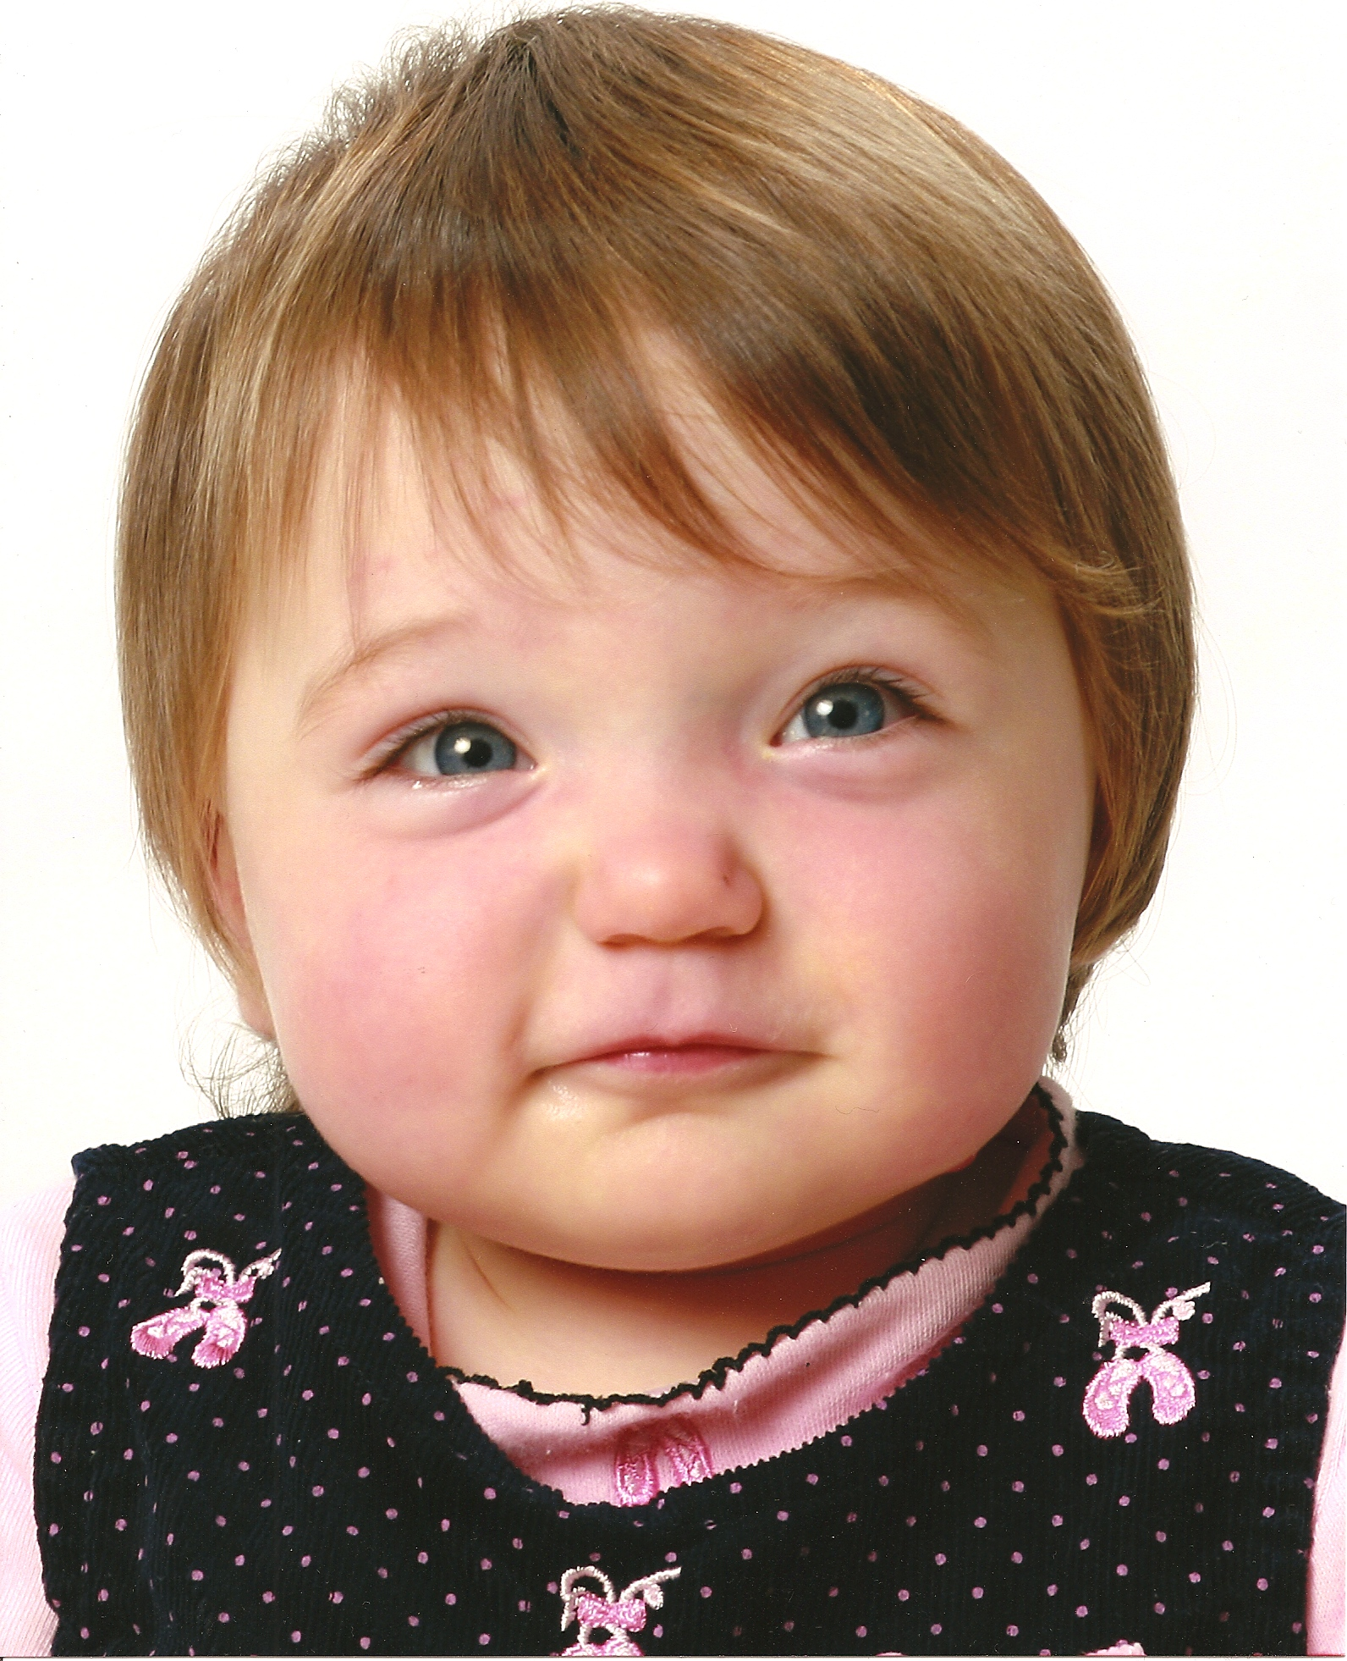  Grace Lynn – one year old, November /2008 | 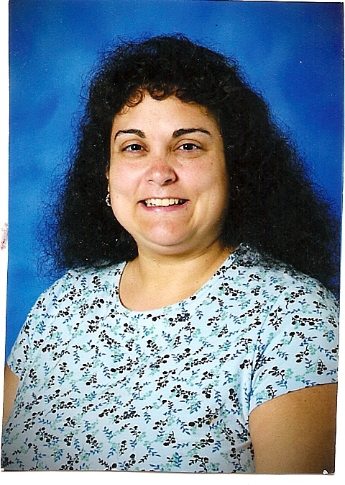  Michelle – Fall 2007  Edisto Elementary School,  Fourth Grade Teacher | 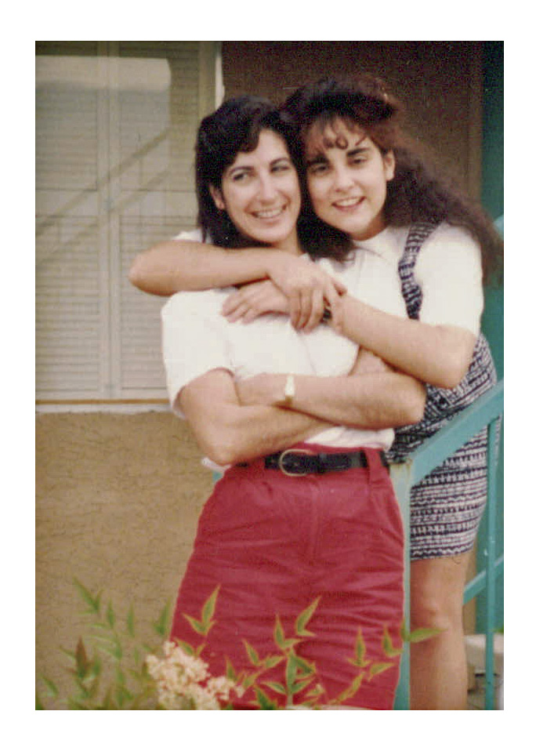  Cindy and Michelle  Tucson, Arizona - May 1990

