**2021 HHS Class Representatives (3pm) and Reunion Committee Meeting (4pm) Minutes**

15 Nov 2020

horizontal line

# Website: <http://www.classcreator.com/Maryville-Tennessee-Heritage-1978-1989/class_index.cfm>

# CURRENT COMMITTEE OFFICERS:

* Chairman: Carmella Lawson (present)
* Co-chairman/Venue Committee: Donna Teffeteller Neal (present)
* Secretary: Carmella Lawson (present)
* Treasurer: Trena Best Conner (present)
* Registrar: Traci Bryant Riches (present)
* Entertainment: Melissa Gurley Glidewell (not present)and Eddie Milsaps (not present)
* Food and Beverage: Suzanne Hearon (present) and Teresa Ward (not present)
* Website: Cheryl Chandler (present)
* Decorations: Cheryl Chandler (present)
* Photos: Alan Riches
* Memories: Suzanne Hearon and (present) Tracy Holder Llewellyn (not present)

# GRADUATION YEAR REPRESENTATIVES:

* 1978: none
* 1979: none
* 1980: none
* 1981: Melissa McKinley Davis (not present)
* 1982: Ronny Hall (not present)
* 1983: Traci Leonard and Emily Miller and Sherry Collins Coffey (present)
* 1984: Emmetta Bailey Everett (present)
* 1985: Shannon Garner Prince (not present)
* 1986: Marty Milsaps (not present)
* 1987: Cheryl Chandler (present)
* 1988: none
* 1989: Teresa Gurley Ward (not present)

# **CLASS REPRESENTATIVE MEETING (HELD AT 3PM)**

# **DISCUSSION TOPICS:**

* **COMMUNICATION**: Traci R
  + Sent emails to all, but only a couple showed up for the meeting.
  + Need to make sure all reps respond to emails that let them know of specific meetings for reps
  + Should also send a Facebook messenger message to the reps individually
* **REUNION COST** discussion – see Reunion committee notes for decision on this topic.
* **REGISTRATION:**
  + Class reps will be responsible for getting as many graduates from their year as possible to register on the website
  + They will also be responsible for creating nametags with a minimum of graduate’s name and senior picture
  + Hope to have enough money to hire some temp hires to work the registration tables
* **TENTS FOR EACH CLASS YEAR:** Based on discussion, each class will have their own tent at the reunion venue as well as a big tent for larger gatherings such as a dance floor, contests, etc.

# **REUNION COMMITTEE MEETING (HELD AT 4PM)**

# **DISCUSSION TOPICS:**

* **FINANCIAL REPORT: Trena Best Conner**
  + **Bank Account** - $1762.59
  + **Pay Pal Account** - $0 (all moved over to the bank account)
  + **Budget updates** – old request updates
    - $1500 for venue (price lowered)
    - $52.80 for 500 postcards to mail out
    - $200 for Facebook boost to advertise for event, working
  + **Budget updates** – new requests
    - Tents, tables, chairs – Suzanne will research
    - Police for venue - $40 per policeman per hour (need 2 for 8 hrs) = $640
      * Required if alcohol at the venue
    - Beer company - $125 for 5 hours to serve beer, need estimate for 7 hours (assume $175)
    - $1 per registration will go to the photographer for editing of pictures
* **REGISTRAR: Traci Bryant Riches** 
  + LATEST NUMBER OF GRADUATES AND +1 SIGNED UP AS ATTENDING:
    - 62 Grad +1
    - 20 solo
  + Will need to have wristbands to give to registrants during registration
  + Discussed “early bird discount”. Decision on final reunion costs are listed below. If event is cancelled, money will be refunded with the exception of each participants $10 deposit (money used to pay for items already paid for)
    - FINAL REUNION REGISTRATION COSTS:
      * Early registration prior to 10 Jan: **$40** per grad**/$20** for their guest
      * 10 Jan to 23 Apr: **$50** per grad**/$30** for their guest
      * Day of event: **$60** per grad**/$40** for their guest
    - Website will not be ready to accept full payments until 1 Dec
  + **Teacher invites**: Donna N – *No updates from HHS of teacher contact information*
  + **Advertising:** *No updates this meeting. Will start this in Jan*
* **VENUE COMMITTEE: Donna Teffeteller Neal**
  + Smoky Mountain Speedway
    - Need draft setup of venue
    - Tour of venue on 3 Nov
      * Determined location for registration, photo booth, food trucks, DJ/bands, tents, parking
      * Participants should bring their own chairs and can bring their own food and beverages to include alcohol.
      * Food trucks will provide food. Will have basic types, but will have more details later. Looking for hamburgers, BBQ, Mexican, carnival food, etc.
      * Will have an area for the photo booth
      * Venue is handicap accessible
      * Will need:
        + A large tent – planning for dance floor here, trivia, award presentation area, etc
        + Tables and chairs in main tent
        + Smaller tents for classes, class reps can decorate as desired.
        + Help with parking, will be provided by Heritage and William Blount HS AFJROTC units as community service
        + Venue has company who can sell canned beer
        + Police – required if we have alcohol, $80 an hour x 8 hrs = $640
    - Melissa G – Still need status of adding insurance for the event to the same contract as the slow ride.
  + Have received approval for Heritage to be the starting point for slow ride and tour of school (11 am – 1 pm)
    - Will be able to tour most of the school on our own, but some areas may be locked or closed off.
* **ENTERTAINMENT COMMITTEE: Melissa Gurley Glidewell and Eddie Milsaps** 
  + **SLOW RIDE**:
  + **AUCTION BASKETS**:
    - Did not discuss giving a discount or free ticket to those participants who provide an auction basket worth at least $40. Will make that decision at the next meeting.
    - *No updates on new items for baskets*
* **FOOD AND BEVERAGE COMMITTEE: Suzanne Hearon and Teresa Ward -** 
  + Suzanne and Teresa – Need to contact Food trucks to let them know of venue and times. Assume about 4 food trucks.
* **WEBSITE COMMITTEE: Cheryl Chandler**
  + <http://www.classcreator.com/Maryville-Tennessee-Heritage-1978-1989/class_index.cfm>
  + Once we have a finalized logo and determine t-shirt costs, need to put set up the website section to sell merchandize
  + Discussed putting list of local hotels, cabins, campsites on the website. Campers can park on the venue (no electric or water, must be self sufficient).
* **DECORATIONS COMMITTEE: Cheryl Chandler**
  + **LOGO**: Committee voted on the logo below created by Misti minus the month and the words Slow Ride and have that replaced with Mountaineers. Emmetta will get in touch with Misti for the final revisions. This logo will be used on flyers, t-shirts, and any other paraphernalia for the reunion.
  + 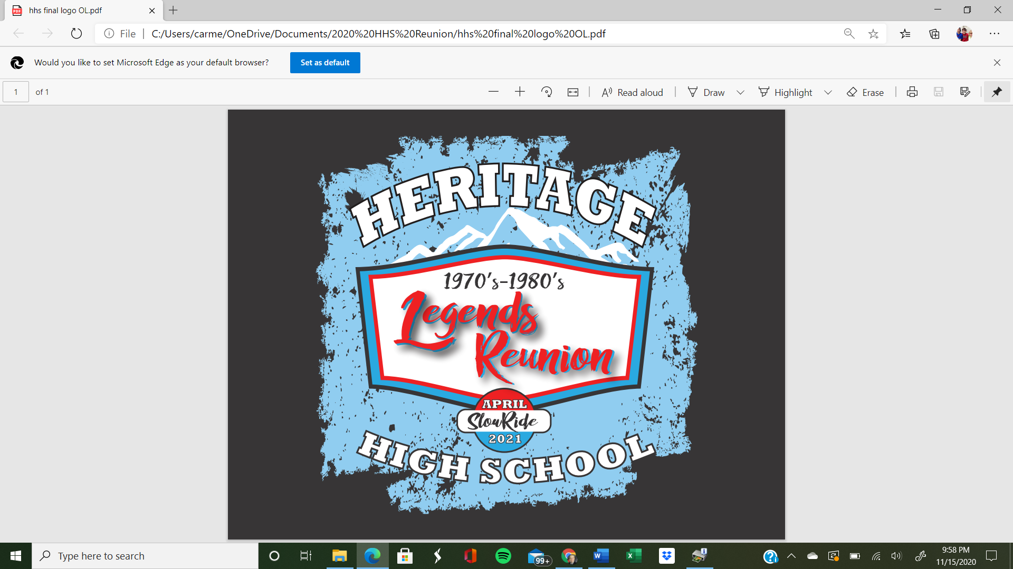
  + **POSTERS**: Cheryl – no updates, awaiting final logo
  + **REUNION PARAPHERNALIA**: Discussed selling t-shirt. No other items discussed.
* **PHOTO COMMITTEE: Alan Riches** 
  + Has a green screen. Will come up with some ideas on what to put on the screen
  + Will edit photos and provide one photo per graduate for free. Other photos will be available for a small fee from his website.
* **MEMORIAL COMMITTEE: Suzanne Hearon and Tracy Holder Llewellyn**
  + LATEST NUMBER OF MEMORIAL NAMES: *Did not get an update this meeting*
  + **MEMORIAL WALL:**  *no updates needed this meeting*
* **OTHER:**
  + For 28 Nov in person reunion committee meeting, Carmella has a call in to Sullivans to use their downstairs party room (holds 25). Will let committee know when that is secured. Shooting for 1 pm if it’s available
* **CLASS YEAR REPS:**
  + STILL NEED 4 CLASS **REPS**

**Committee Suspenses (bold items are new, italics are completed)**

* + *26 Sep Melissa Agenda draft created – COMPLETE*
  + *29 Sep Cheryl Establish Website – COMPLETE*
  + *29 Sep Traci Establish Paypal option for registration – COMPLETE*
  + *29 Sep Trena Open Bank Account – COMPLETE*
  + *1 Oct Traci Registration Form on website – COMPLETE*
  + *15 Oct Melissa/Eddie Reserve Band/DJ – COMPLETE*
  + *15 Oct Trena Budget Draft – COMPLETE (in folder)*
  + *15 Oct Melissa/Carmella Charities contacted – COMPLETE*
  + *15 Oct Donna Contact HHS for start of slow ride – COMPLETE*
  + 28 Nov Misti Draft Reunion Logo
  + 28 Nov Carmella/Melissa In-person Meeting of Reunion Committee in Maryville
  + *28 Nov Donna Secure HHS tours on the morning of event - COMPLETE*
  + *30 Nov Class Reps Class Yr Names Spreadsheet to Cheryl for website -COMPLETE*
  + 30 Nov Donna/Suzanne Determine draft setup of venue, what will be where
  + *6 Dec Suzanne Secure venue (Smoky Mtn Speedway) - COMPLETE*
  + 15 Dec Suzanne Reserve Food / Drink Source - Food trucks
  + **10 Jan End of “Early Bird” Discount Registration**
  + 15 Jan Carmella/Melissa Start advertising (billboards, TV, Radio, paper)
  + 1 Feb Donna Invites to Teachers
  + 1 Feb Melisa Ensure we have a stage for the bands
  + 1 Feb Cheryl Order t-shirts or other paraphernalia for give aways or sales
  + 1 Feb Donna Tents / Chairs / Tables secured for event
  + 1 Feb Melissa Determine costume categories and complete awards
  + 1 Feb Alex Create Class photo schedule
  + 1 Feb Cheryl/Traci Link photographer website to reunion website
  + 1 Mar Class year reps Class reps scan/print/crop pictures for nametags
  + 1 Mar Suzanne Pictures printed for memorial wall / memorial wall constructed
  + 1 Mar Melissa Slow ride/venue insurance secured
  + **1 Mar Melissa Create Slow Ride Voting Ballots**
  + **1 Mar Melissa Release of Liability Forms printed and ready for Slow Ride**
  + **1 Mar Suzanne Secure policemen for security**
  + 1 Apr Cheryl Have items for memorabilia table together – classes may have their own
  + 1 Apr Cheryl Complete photo booth decorations
  + TBD Secure permits required

**NEXT COMMITTEE MEETING: Sunday, 6 Dec @ 4 pm HHS time**

**GENERAL NOTES FROM PREVIOUS MEETINGS**

* **WEBSITE**: <http://www.classcreator.com/Maryville-Tennessee-Heritage-1978-1989/class_index.cfm>
* **EVNET DATE**: 24 April 2021
* **VENUE**: Smokey Mountain Speedway, 809 Brick Mill Road, Maryville, TN 37801
* **ITINERARY**:
  + 11 am -1 pm: Heritage HS tour and registration
  + 1-2 pm: Slow ride from HHS to SM Speedway
  + 3 pm: People show to SM Speedway
  + 3-6 pm: DJ
  + 4 pm: Opening ceremony
  + 4-8 pm: Food Trucks
  + 4-9 pm: Trivia, Corn Hole, Costume Contest, Photo Booth
  + 6 pm: Announcement of Award Winners
  + 7-10 pm: Bands
* **FINANCES**: Priority for money received from attendees will be to spend on the event; however, any leftover money will be donated to charities listed below and they will have . Monies from auction baskets will be donated to these charities.
* **CHARITIES**
  + American Cancer Society – Melissa G: committee contact; Kayla Shelby: org contact, [kayla.shelby@cancer.org](mailto:kayla.shelby@cancer.org)
  + Mission 22 – Carmella Lawson: committee contact, Tim Fry: org contact, [loadtoad65@gmail.com](mailto:loadtoad65@gmail.com)
    - Website: [www.mission22.com](http://www.mission22.com)
* **Music**: All reserved
  + DJ: Josh Livingston
  + Bands: Kinkade and Hardwired
* **Advertising – on hold until after the holidays**.
  + Discussion was had to limit the TV and radio announcements given the current state of COVID. Will look to start this after the holidays.
  + Public service announcement on radio channels
  + Billboards - Carmella provided cost information for digital billboards
  + Daily Times/TV stations - Carmella emailed all but they have not returned info. Jeff Wagner has contacted Carmella and he has contacts at Ch 6, Ch 8, Ch 10 and the Daily Times