To Rita & Jim Kearns
116 Nottingham Rd., Columbus Oh
Lost? Not For Long – 614/263-6410
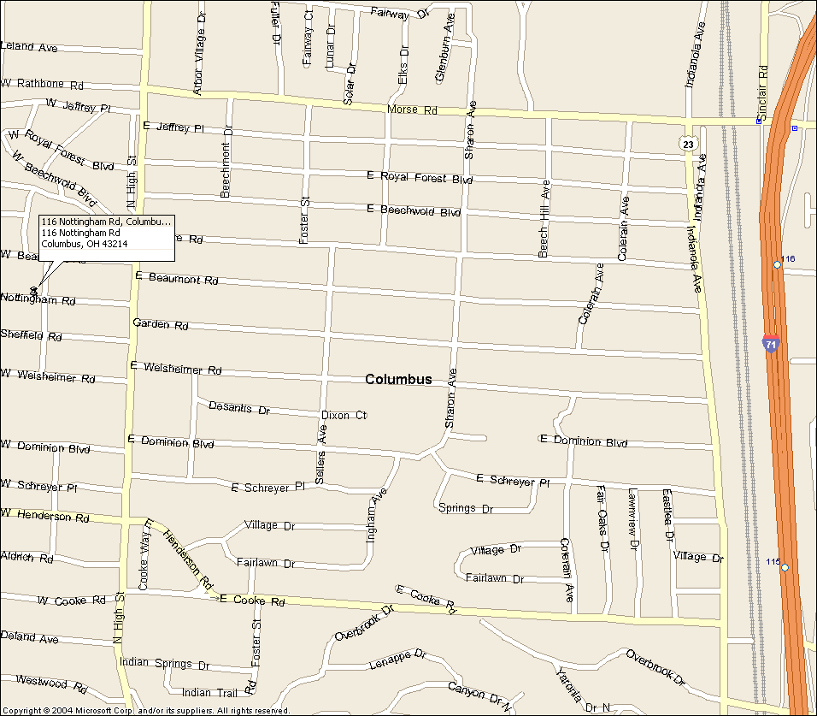

To The Warehouse
320 W. Center St., Marion, Ohio
(Remember - One Way West)
