Chapter 5 - Boy Scouts
Between the ages of 11 and 14 I had two passions. Once I turned 14 and discovered girls, I forgot all about both of them, but until that age I was obsessed with only two things in life: Little League baseball and Boy Scouts.
My Dad had been an Eagle Scout — he said that he had been the youngest Eagle Scout in the state of New Jersey — so he was keen on signing me up to be a Scout just as soon as I turned eleven. It was probably on my very birthday that he drove me to the Scout lodge and got me registered. (There are Mexican Scouts, as well, but their uniforms are different, and, of course, everything they do is in Spanish, whereas we were American Scouts, and all our activities were in English.)
As it turned out, there was a one-week camping trip planned for the next week, and I got signed up just in time to be able to participate. We barely had time to find a uniform for me. The camp was near Tepoztlán, now a new-age town full of ex-hippies, but at the time it was just another sleepy Mexican village at the foot of a steep mountain, sacred to the Aztecs, called El Tepozteco.
I only remember two things about my short stay at that camp. The first was a day hike up El Tepozteco, at the top of which is a large temple to Tepoztécatl, the Aztec god of pulque, that god-awful fermented maguey-plant juice. It was a pretty rigorous hike under the brutal mid-day sun, but we all managed to get to the top where we imagined there were Aztec warriors lurking behind the rocks and trees, guarding their holy site.
The other thing I remember about this camp was that it had a row of trees behind our tents — maybe seven or eight medium-height trees, planted fairly closely together so that their branches met. One fine afternoon I decided to climb the first tree in the row, and, once up there, I discovered that I could get myself onto the second tree by climbing directly onto its branches. And then to the third tree. And so on, until I got to the end of the row, at which point I climbed down. Such fun! And good for bragging, too. I ran back to the first tree and did it all over again, and maybe even a third and a fourth time, until, inevitably, I missed a branch and fell perhaps fifteen feet to the ground. With blood coming from a gash on the top of my head, the scoutmaster rushed me to the Cruz Roja hospital in nearby Cuernavaca, where my broken arm was set and six or seven stitches were put in to close my head wound. My parents had to come pick me up, and that was the end of my first camping trip. Back home, our family doctor, Dr. Villalobos, discovered that the Cruz Roja hadn’t properly cleaned my wound, so he had to remove the stitches, clean and disinfect it, and re-stitch it. Ouch!
In spite of this inauspicious start to Scouting, I liked its rituals, the uniform, and the camaraderie. I belonged to Troop 4, which was for all the boys who lived on the south side of the city. Mr. Gottfried, a former fighter pilot in the U.S. Air Force, was our scoutmaster, and he did his best to bring military discipline to us young Scouts! The troop was divided into several patrols of six or eight boys each. The boys who lived in the Pedregal, of which I was the youngest, decided to form our own patrol, and instead of choosing one of the normal animal names, like “bear” or “fox,” we decided to call ourselves the Indri Patrol. Since no one had the slightest idea what an indri was, we would delight in impressing them with its dictionary definition: “a large, short-tailed lemur, native to Madagascar.” In addition to the regular scouting pursuits, our patrol had lots of other fun activities — spaghetti-eating contests, swim parties, movie outings, etc. We were by far the coolest patrol in the troop.
We Indris had an amazing “lodge,” consisting of a large, wooden moving crate that had been used by the parents of Ross Demme, one of our new patrol members, when they moved to Mexico. It had been conveniently transported to the vacant lot next to our house, so, naturally, I became the patrol quartermaster. This meant that I had sole possession of the keys to all four of the locks that we used to secure our sacred meeting place, where no adults, girls, or other outsiders could enter. Inside our lodge were all kinds of scouting paraphernalia, plus an impressive collection of Playboy magazines that some of the older boys had brought in. Not everything a Boy Scout learns is to be found in the official Boy Scout manual!
Besides hanging out with my fellow Indris, my favorite part of Scouting was the camping trips, the best ones being those that took place at a camp located in the pine-forested mountains near Valle de Bravo. These semi-annual outings were open to all of Mexico City’s four troops, and well over a hundred boys would attend them. Since the Boys Scouts is pretty much a junior military, with its uniforms, salutes, hierarchy of ranks, loyalty oaths, etc., American military veterans living in Mexico City willingly aided our activities by donating the huge army tents we slept in, built the mess hall at the main camp, served as Scoutmasters, and in many ways made Scouting possible for us boys.
I vividly remember the old campesino custodian of the Valle de Bravo camp, a man by the name of Ignacio (“Don Nacho” to everyone). He wore the traditional, indigenous, white cotton peasant garb; he had a full head of white hair, a huge mustache, and he always wore a big sombrero and carried a machete. He was a vestige of Mexico of a previous era. I could barely understand his gruff Spanish, but I remember his telling us how, during the Mexican Revolution of 1910-17, the rag-tag revolutionary forces came through the farm where he was working. “The Zapatistas came down the hill and marched right past us, on their way to take the town from the forces of Huerta.” We had read about the Revolution in school, but Don Nacho was living history!
I loved going to camp. We’d start the day with an early morning swim in the cold pool, then there would be breakfast in the mess hall, then inspections of our tents, personal belongings, uniforms, and even our personal hygiene. I remember the command “present hands!” to which we’d have to show that our hands and fingernails were clean. After that we were free to work on our merit badges, engage in some inter-troop competitions to determine, for example, which troop could build the best log tower, or spend some time just hanging out. The youngest scouts were frequently targets of innocent deceptions to the great amusement of the older boys. For instance, an older boy, working on a tower, might ask a first-time camper to “go ask Mike for the “sky hook,” or the “left-handed monkey wrench,” or some other non-existent tool. Mike, wise to the prank, might tell him that Jim had it, and the hapless boy would be on a wild goose chase all around camp. At dusk, first-time campers were also led on “skipe” hunts. Their gullibility was a source of great amusement to the older boys, but the next year the younger boys would be in on the pranks, and they’d be eager to initiate a new set of boys.
On one very special night during each camping trip there would be huge bonfire, located deep in the woods away from camp, and we would be led there by members of the secret Order of the Arrow, all dressed as American Indians, complete with painted faces. The 100+ Scouts would stand in a circle around this bonfire to witness some lucky boy’s initiation into the Order — one of the two ultimate achievements for a Scout, right up there with the rank of Eagle. To the beat of an enormous drum, the highest ranking member of the Order, dressed as an Indian chief, with war paint and headdress, would run around and around the fire, inside of the circle of boys. At some point in his circuits he would give a hard push on the chest to the newest initiate into the Order, knocking him to the ground. After being “tapped out,” the boy would be led away by other Order members to some unknown location where he’d spend the night alone. He’d then spend the next day wandering around camp, forbidden to speak, doing chores for the Order members. If he uttered a word, an Order member would carve a notch in the stick that he was required to wear, attached to a string around his neck. If he got three notches he would be expelled. It was a huge honor to be admitted into the Order of the Arrow, and it wasn’t until my last year as a Scout, the year that I achieved the rank of Eagle, that I was accorded that honor. After going through my pledge period I was inducted into the Order in a secret ceremony and given the prestigious white sash emblazoned with a red arrow.
Sadly, my Order of the Arrow sash somehow got lost in my many moves, but I’m still proudly in the possession of my merit badge sash, complete with the required 21 badges, as well as my Eagle Scout ribbon and medal. At the age of 13, I became the youngest Eagle Scout in Mexico City, and it’s a good thing I reached my goal so quickly because I soon became interested in girls, an interest that was totally incompatible with Boy Scouts.
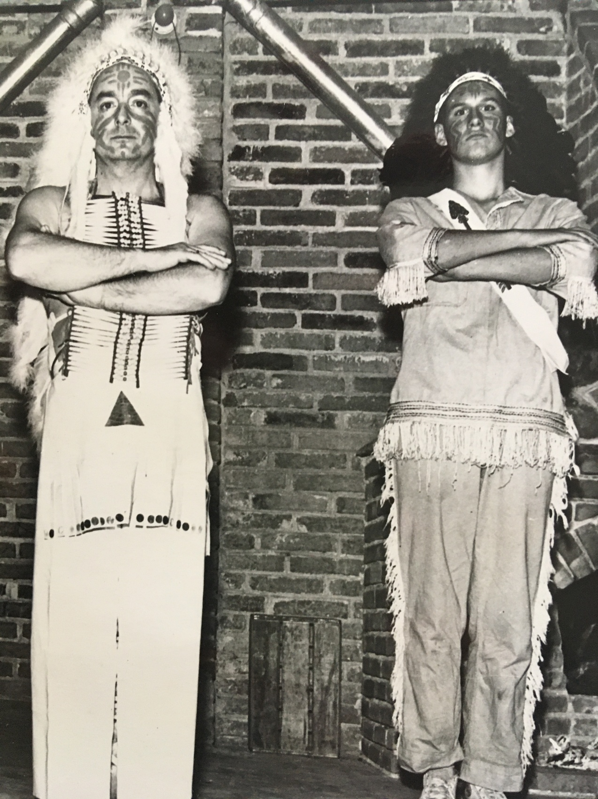Mr. Pérez (our Order of the Arrow advisor) and me.
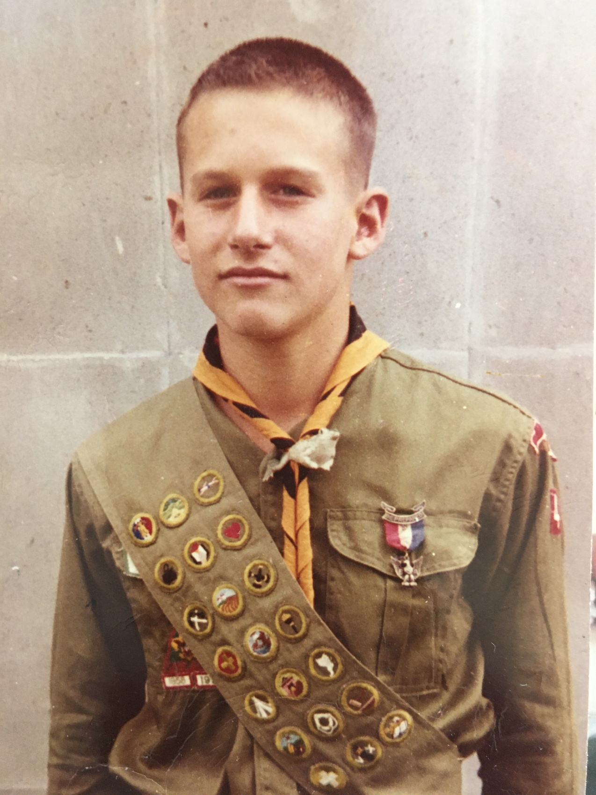Eagle Scout, September 1960
© Copyright 2021. Property of Robert Ogden. If copying, please attribute to author.

Chapter 6 - Junior High School
These days, it’s called “middle school,” but in the 50s and 60s the term we used was “junior high,” and it consisted of two grades: 7th and 8th. At the American School, the elementary school was in one building and the junior and senior high were in another, with the cafeteria and the “multi-purpose building” (auditorium/gymnasium) between the two. The two buildings were not very far apart physically, and yet they were worlds apart.
In the elementary school half the school day was taught in Spanish, and the Mexican government’s official curriculum was covered. That’s where we learned Mexican history, of course, but we also were taught science and math in Spanish. In the English half of the day we learned U.S. history, as well as science and math, albeit taught differently. Once we got to junior high, however, almost all the classes were in English, with the exception of a few classes in Mexican history and literature for the kids who wanted to attend Mexican universities.
Unlike elementary school, the school day in junior high was divided into 50-minute periods, and each period was taught by a different teacher. Between classes we were free to go to our lockers to drop off books and pick up whatever we needed for our next class or classes. For a 12- or 13-year old, having one’s own locker with its combination lock, plus the freedom to socialize, if only for three or four minutes, is a very big deal.
I remember certain teachers really well. One was our 7th grade math teacher, a big, jolly, heavy-set man by the name of Humberto López Pineda, or “Mr. Pineda” to all the kids. He took a personal interest in all of us and gave us the kind of guidance and advice that helped us deal with the concerns typical of most adolescents — peer pressure, fitting in, awareness of the opposite sex, etc. He was a good teacher —I still remember his “regla de tres” for figuring proportions — and he was a wonderful human being.
Another memorable teacher was Mrs. Hayward, the 8th grade math teacher who taught us algebra. Her personality was just the opposite of Mr. Pineda’s, but I loved her class, the precision of her subject, and the methodical, no-nonsense way she taught it. We had daily quizzes and weekly tests, and I got an “A” every marking period. Since Mrs. Hayward sat us alphabetically, I sat next to a new kid in school by the name of Jerry Newgord, and he was good at math, too. Maybe I shouldn’t brag about my math prowess since I had my comeuppance in calculus a few years later, but in 8th grade algebra, Jerry and I were pretty good.
Right after algebra class, Jerry and I went straight to our wood shop class down in the basement, taught by a man by the name of Agapito Flores. We were always amused by the name “Agapito” because it was such a hick name. Agapito was clueless about boys our age, and I couldn’t imagine why the adults had hired someone like him to teach junior high school boys. I suppose there weren’t a lot of people who were skilled in woodworking who had also studied adolescent psychology. But what is even more astonishing is that the school board and the administration allowed a bunch of wild-ass 13-year olds like us to operate table saws, drill presses, lathes, and other dangerous tools. Some of the boys (shop was only for boys; the girls took home-ec) were pretty creative and even skilled, but most of us were nothing but a menace to ourselves and to our classmates, especially Jerry and me. I remember once I took a piece of 1” x 6” board and, with the table saw, cut it up into one-inch cubes for the sole purpose of stockpiling ammo to throw at other kids when Agapito wasn’t looking. I wish I could remember the lame reason I gave him when he asked what project my cubes were for.
Jerry, like a lot of kids that age, was good at giving people nicknames. He called me “Chayote,” that being a form of squash with a smooth skin, similar to my head. He fancied himself as “Nalgas” (buttocks) because he imagined that he had such an attractive ass. That moniker might have had more credibility if it had been given to him by the girls, but since they hadn’t, well, Jerry just gave it to himself. The best nickname was the one he devised for Señor Flores: “Haga Pedo,” which sounds very close to “Agapito.” “Haga pedo,” if your Spanish is rusty, means “make a fart.” It was a laugh a minute with Jerry Newgord.
Our eighth-grade science teacher’s name was Mr. Mosher. One of the few things I remember learning from him is that when you smell something it’s because molecules of that substance have entered your nostrils. He told us to remember that whenever we’re in a stinky bathroom. I still do.
My favorite class, however, was always gym. Since it was never real winter in Mexico City, we could go outdoors everyday of the year. We’d play flag-football, soccer, and baseball. But there were also indoor sports, like volleyball, gymnastics, and basketball. For a 7th-grader, the novelty of gym class was the locker room, and that was a source of anxiety for everyone, I’m sure, with the onset of puberty. We had to take showers after every gym class, and that meant getting undressed and being exposed to all the other boys. And since kids develop at different rates, there was always a lot of looking, if not actual commenting or teasing. Oh, adolescent boys!
Another aspect of the locker room was the towel-snapping. There’s nothing that stings quite so much as a snap on your bare ass with a wet-tipped towel. The trick to avoid being snapped was to play offense: always be on your guard, be quick to execute your snap first, and then quickly jump back before your target can retaliate. Also, get dressed as quickly as possible and leave.
The best part of the day, of course, was recess. After wolfing down our lunch, we 7th grade boys would engage in wrestling matches on the grass. I was one of the biggest kids in the class, so I could beat most of the other guys, but not a tough, wiry kid by the name of Dorian Brazy. I just couldn’t pin that guy. Again I must ask, “where were the adults?” How could wrestling matches on the grass be an acceptable recess activity?
After school there were various clubs and activities we could participate in. The only type that interested me were the sports. In junior high I got to play basketball in the “winter” and do track & field in the “summer.” That meant riding the late bus home, a 40-minute ride with a goofus by the name of Grant Brandon, a fellow who would become my lifelong friend.
Grant was another new kid, having arrived with his family from Cuba, exiles from the Cuban Revolution. Grant’s dad was the owner and president of a chemical distribution company in Havana, but when Fidel Castro came to power he lost his home and his business. Nearly penniless, the Brandons arrived in Mexico to start over. Fortunately, Mr. Brandon, a very capable guy, found employment pretty quickly, and Grant and I became good friends. There will be more about him in future entries, and about Jerry, too.

© Copyright 2021. Property of Robert Ogden. If copying, please attribute to author.

Chapter 7 - Junior High School Crushes
Until about the age of about thirteen, girls are just an annoying fact of life for boys, but then, without warning, they become very interesting and, at times, an obsession.
My earliest recollection of sitting up and taking notice of the opposite sex was in sixth grade. The object of my infatuation was a girl named Sally Jones. Yes, that was her real name. But the thought of approaching her and asking her to "go steady" with me was terrifying, so I took the coward’s way out and wrote her a short note asking if she would consider such a proposition. But, being entirely new to this business, I was too frightened to even hand her the note, so I asked one of her friends to do so. To my utter amazement, Sally agreed, and we exchanged name bracelets — the kind that were popular in the 50s. I was thrilled at the idea of going steady with her, but then it dawned on me that I might actually have to talk with her, a frightening prospect. I put it off and put it off, until finally, about two weeks later, I got a note from her saying that she wanted to break up and could she please have her bracelet back. I couldn’t figure out why she was through with me — was it something I said? (No, it couldn’t have been that.) But, frankly, it was a huge relief, and I put off this girls business for another year.
My next romantic endeavor was with a tall, skinny girl by the name of Drucilla Martin. I actually talked with her a few times. In fact, we went on a date together. Sebastián, our driver/mentor/life coach, drove me to her house and took us to the movies, I believe, and then drove us back. The only thing about this date that I remember, and I remember it very clearly, is that Drucilla and I were sitting in the back seat of the car, far apart from one another, when we pulled up to her house. She thanked me, got out, and went to ring her doorbell. Old Smoothy here said “good-bye” as she exited the car, and then waited there until someone opened the front door for her, at which point we waved to each other. Oh, the grief I got from Sebastián! “¡Roberto! ¡Cómo eres menso!” (roughly, “you idiot”) “Why didn’t you get out of the car and walk her to the door? You’ll be lucky if she ever goes out with you again!” He was right; she did not.
Once I got into eighth grade, I started to take this girls business more seriously. Without warning, I was thunderstruck by a glamorous girl by the name of Zia Shields. Zia didn’t go to our school; in fact, she didn’t even live in Mexico. She was the summer guest of the Bano family, whom I will describe in a few minutes.
Zia was exotic. And obviously very rich. Her father, Alexander Shields was a well-known clothing designer in New York. This is from a N.Y. Times article, dated May 30, 1960:
“Among the most personable young couples in the fashion world are Mr. and Mrs. Alexander Shields, the attractive pair behind the Alexander Shields label. Mr. Shields, an adventurous designer of men’s clothes whose shop is at 484 Park Avenue, also sells his designs to fifty top stores around the country…”
I met Zia at a party at the Bano's house, and I was immediately smitten. Much to my delight, she seemed taken with me, too. She was the first girl I ever kissed, and oh, how she could kiss! Had she perhaps been to France? I was in love, no doubt about that, and I was sure that she was, too.
But as fate would have it, a week after this amazing encounter my family departed on a two-week trip to visit my grandparents in Michigan and New Jersey. Before I left I gave Zia my grandmother’s address in New Jersey, and we promised to write to each other every day. I knew that no mail would reach me while I was in Michigan, but by the time I got to New Jersey I expected at least two letters. After all, I had written every day, as promised. But when I got there, there were no letters for me! I waited for the mailman the next day, but there was nothing then, either. Or the next. Or the next! I was devastated. Ironically, the song “Mr. Postman” by the Marvelettes, was a #1 single that year, and I couldn’t get it out of my head. It seemed to have been written for me. I tried to have fun at the shore house, but about all I could do was think about was Zia and wonder why I hadn’t gotten her letters. When I got back to Mexico I found out the reason: she hadn’t written any! In fact, she had been going out with Ross Cummings, one of the coolest guys in the school who was at least two years older than me. This was my first experience with heartbreak. Not that it was any consolation, but Ross probably had his heart broken, too, when Zia’s excellent Mexican adventure came to an end a few weeks later and she returned to her parents’ penthouse on Park Avenue.
My mother once said that the best part of living in Mexico was not the climate, even though that was wonderful, nor the lifestyle, which was amazing for a poor Michigan girl like hersself, nor the food, nor the culture, nor anything else you might imagine. For her it was the fact that she was able to meet so many interesting and accomplished people. Among the most fascinating people who lived there were the Banos. Jenny Bano was a classmate of mine, and her mother and my mother were best friends. The Banos lived in a house straight out of a movie set, but even more impressive than the house itself were the animals they kept, including a seal who hung out in the swimming pool and a full-grown leopard which roamed around inside the house. This leopard was apparently the Banos’ idea of a domestic cat. Mrs. Bano, who must have been some kind of animal trainer at the Mexico City zoo, once borrowed a boa constrictor and took it to our house. After asking my mother to put our (traditional) cat safely outdoors, Mrs. Bano took the boa out of its basket, and Mom , Mrs. Bano, and my sister Polly watched it slither around on our living room floor. Then, one by one, they picked it up and allowed it to wrap itself around their necks, exerting just the slightest squeeze. One does not meet many people like Pat Bano in one’s lifetime.
As if these animal antics weren’t amazing enough, Mrs. Bano was also a hula dancer, and it was quite something to watch her perform in her hula skirt. It shouldn’t come as any surprise, therefore, that her daughter Jenny was just as just as flamboyant as she was, and having now forgotten Zia, I fell for her. I went to her house a few times, but I was always a bit uneasy, thinking that the leopard might decide that any display of affection on my part toward Jenny might be misinterpreted…
Even as an 8th grader, Jenny was strikingly beautiful with her long blonde hair and lissome body. My sister Polly described her as “a Brigitte Bardot look-alike.” Jenny briefly showed some interest in me, but a serious relationship was not to be as I was still too shy around girls. The lucky guy who was won her over was my good friend Tommy Mount. Tommy had something that I certainly did not have at age 14 — the ability to charm the girls and make them laugh. All I could do was look on with envy — until I met Nancy! But that’s a story for a future chapter.
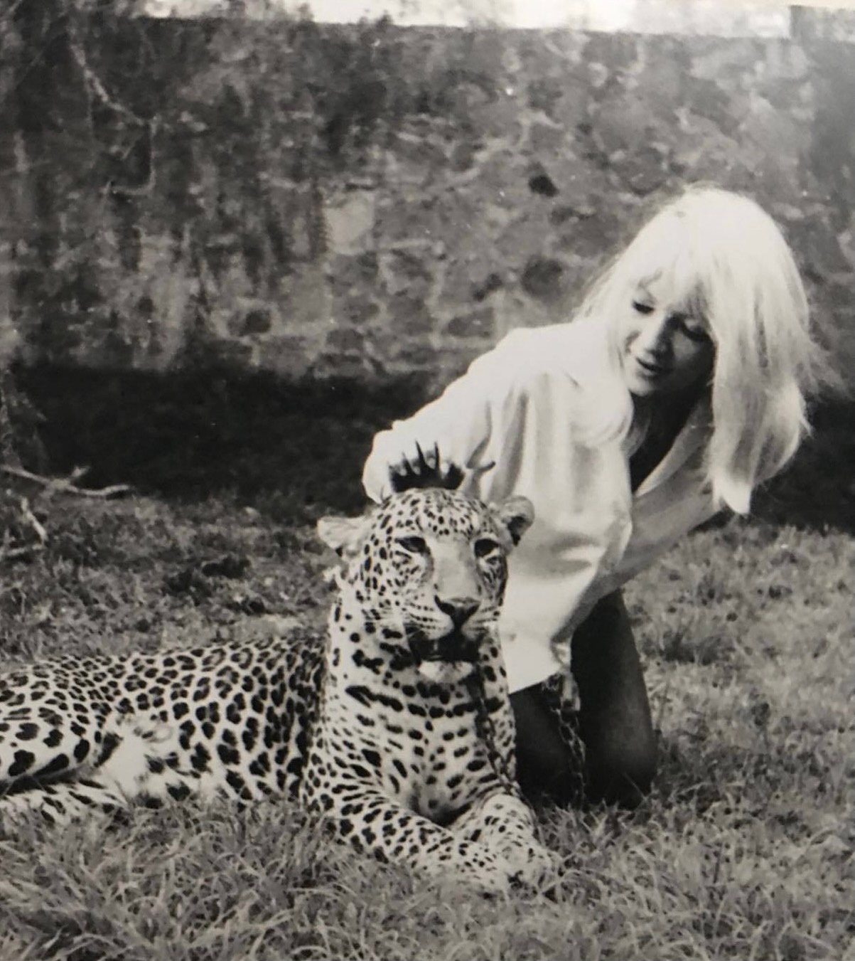
Jenny Bano and her leopard
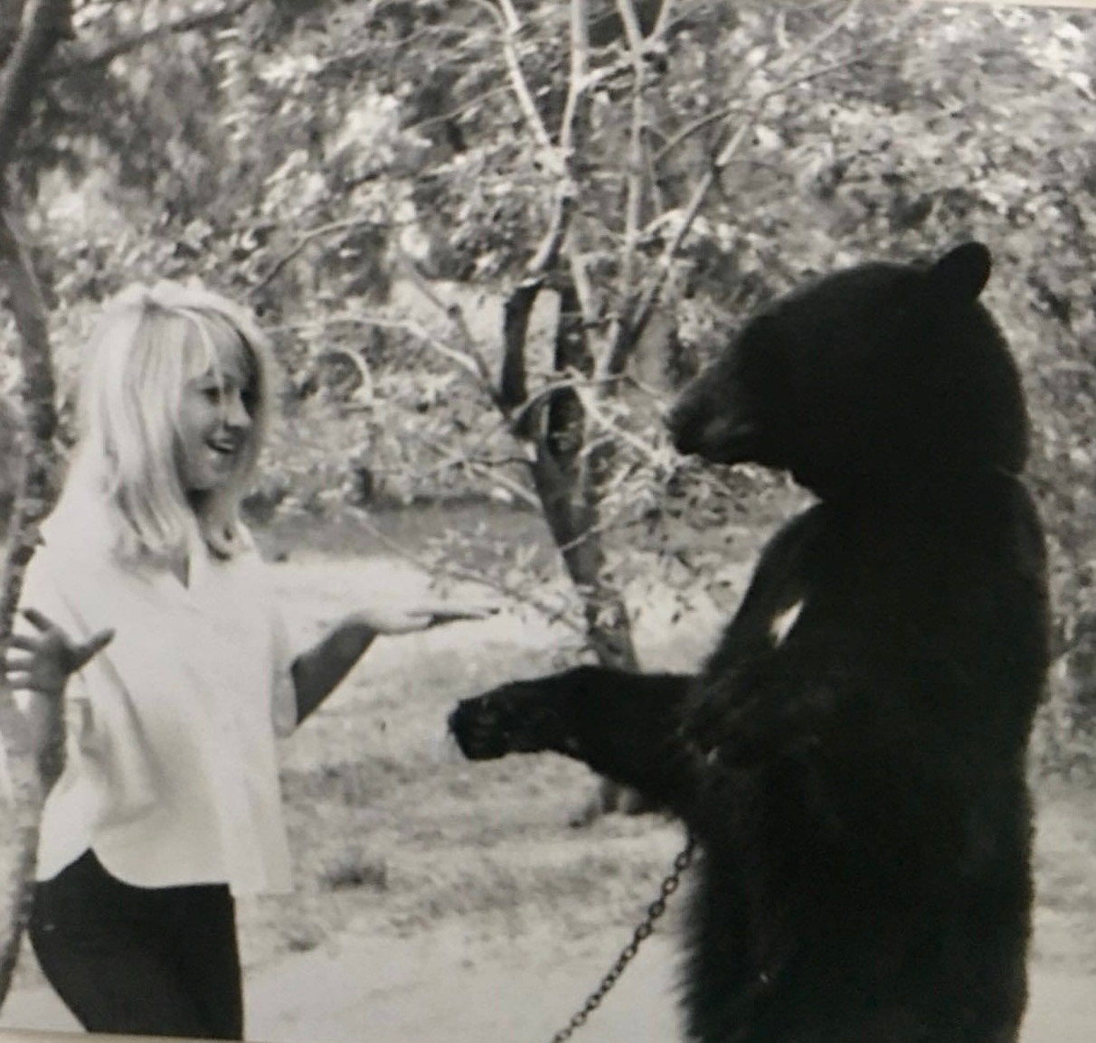
Jenny, the bear trainer
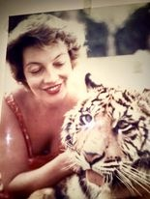
Mrs. Bano with her Bengal tiger. “Kitty, kitty.”

© Copyright 2021. Property of Robert Ogden. If copying, please attribute to author.

Chapter 8 - Debacle on Little Nell
After we had been in Mexico for a year or so, my parents decided that we should go on a road trip to California to visit my father’s sister and her family who were living in Long Beach. So Dad had a rack attached to the roof of our ‘56 Ford station-wagon — less than a year old at the time — and we began the first of several unforgettable road trips.
My Uncle Lindy was a captain in the Navy, and he had recently been transferred to Long Beach. Since we hadn’t seen him, my Aunt Lucky (Lucile), or their three sons in quite a while, and since none of us had ever been to California, Mom and Dad decided that a visit was in order. Never mind that this involved driving almost 2000 miles, mostly in Mexico on less than wonderful roads — there were no “autopistas” or Interstate highways in the 1950s. It must have taken at least 40 hours — four solid days of dawn to cocktail-hour driving. (We had to be at our stop for the night by 6:00 p.m.) But since the vehicle was a station-wagon, that meant that the entire area behind the driver and passenger seat could be laid flat — perfect for stretching out and taking a nap. So, in spite of the fact that cars did not have air-conditioning in those days, or even FM radios, we were able to rack up the miles in relative comfort. Modern-day Okies, crossing the desert, heading to California!
California was a lot different from Mexico. There was a Safeway grocery store just a few blocks from my aunt & uncle’s house, and it was stocked with so many things that weren’t available in Mexico: Tootsie Rolls! Peanut butter! Root beer! These were delicacies that we had been deprived of since leaving Michigan. One day I walked to the Safeway with my meager allowance to buy a pressurized can of whipped cream — such a treasure! — and, hiding behind the store, I gluttonously filled my mouth again and again with that heavenly substance.
Southern California also had Disneyland, which had just opened, and we were among the first-ever to visit this incredible place. We also visited Hollywood — Mom and Dad just had to see the corner of Hollywood and Vine, the famous meeting place of the stars — and then drive over to Beverly Hills to cruise along Rodeo Drive. “This is where all the movie stars live!” Mom exclaimed.
My aunt and uncle’s house was not very big, and it must have been a bit of an imposition for us to be there. I imagine they were delighted when we left after about five days, to make the long drive back to Mexico City. In retrospect, that seems like an awful lot of driving to spend a few days with our relatives and to see the Golden State, wonderful as it was.
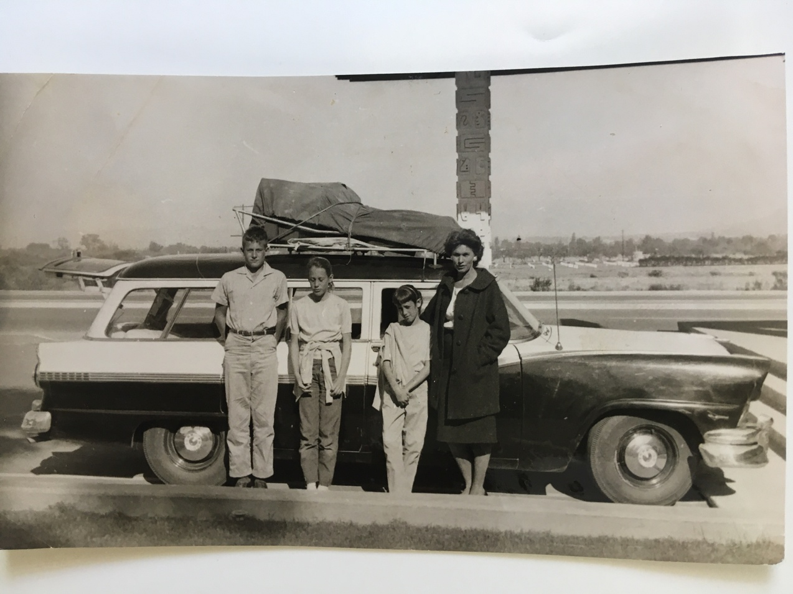
Heading to California on our first big road trip. 1957
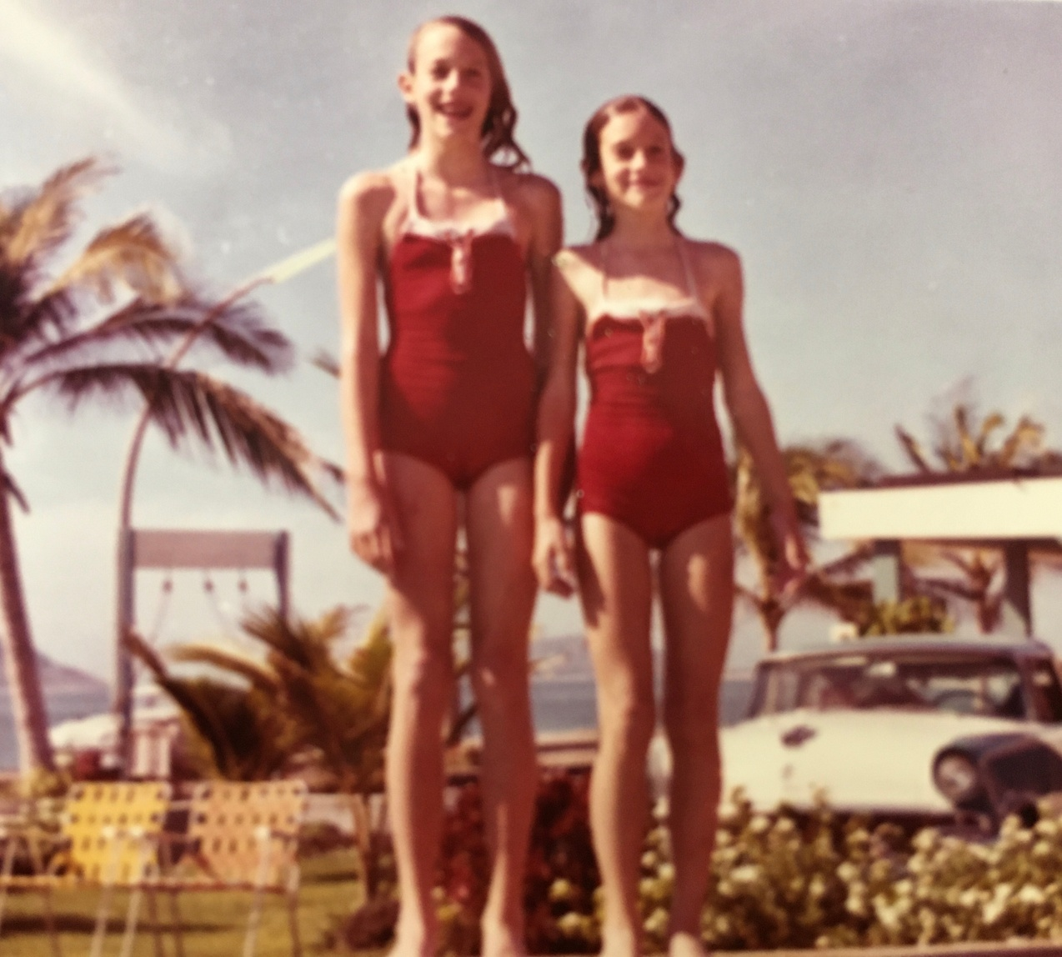
Deb & Polly at a motel pool, on the way to California.
Apparently Mom and Dad weren’t bothered by endless days on the road, because a few years later we went on another road trip, but this time the destination was Aspen, Colorado, again almost 2000 miles from Mexico City. This was in the winter of 1961-1962, I was not quite 15 years old and in ninth grade, and we were going to go skiing!
Dad had skied a little when he was in college, and he and Mom went to Mont Tremblant for their honeymoon, but for all intents and purposes we were all novices. Even though Dad talked a good story.
Aspen was just a little town back then, mostly unknown to the world except to some hardcore skiers. Dad had heard that it was “the” place to ski, if you could get there. At $6 for a Saturday or Sunday pass, and $5 for a weekday pass (with weekly discounts available), it was not outrageously expensive. (I just checked: it’s now $194 for a Saturday or Sunday pass, and $179 for a weekday pass.)
I said “if you could get there.” Interstate-70 and its Eisenhower Tunnel had not been built yet, so the only way to get to Aspen was over a couple of mountain passes, one of which was the 12,000-foot high Loveland Pass. If we’d had any sense at all we would not have attempted to cross the pass that day because there were basically blizzard conditions with almost zero visibility. Chains (and no brains) required. But Dad didn’t want to “waste” a day of his precious vacation time, so we somehow managed to attach the chains and off we went, into the wild white yonder. We would have ended up at the bottom of some ravine, I’m sure, except that we got behind a car full of University of Colorado students who, likewise, didn’t want to waste a day of skiing. Two of them walked in front of their car, guiding it safely across the pass. Wisely, we followed them, arriving safely in Aspen that afternoon.
We checked in at the Blue Spruce Inn, just a few blocks from the main lift. Dad had arranged for us to take lessons, beginning on Monday, but since we arrived on a Saturday afternoon and we were all eager to see what skiing was all about, we went to the ski shop, picked up our skis for the week, and the next day we hit the slopes — without the benefit of a single lesson.
It was still snowing heavily, the wind was howling, and visibility was still very limited. “Oh well, it always snows here, doesn’t it?” Dad said. Besides that, he assured us that we wouldn’t be doing anything too challenging — we would ski a slope by the name of Little Nell, right at the base of the mountain. Little Nell is classified as “novice,” and so is Upper Little Nell, although this latter slope is quite a bit steeper than the former. But we wouldn’t ski the upper slope, we’d stay on the lower one. Right?
The ski patrol could have foreseen what would happen that day as we walked from the hotel to the ski lodge, repeatedly dropping our skis and bags along the snowy sidewalks. Then, once there and our skis on, we kept tripping over them as we awkwardly made our way to the lift line. A disaster waiting to happen.
The lift was a two-person chair, which meant that one of us would have to go up alone. That person was me, and I was the last to get on, so I saw what happened to my sisters and my parents who were in front of me. My sister Debbie and Mom were in the first chair. God only knows how they managed to get on it without falling down; I think the lift attendant stopped the lift for them. In any event, the plan was for them to get off at the first off-ramp, but much to my Dad’s horror, they didn’t, and they headed up to the top of Upper Little Nell. My guess is that the reason they didn’t get off is that they were too scared to, but Mom swore that she “just wanted to see how other people did it” before doing it themselves. Be that as it may, they wound up at the top of Upper Little Nell, and this time the lift attendant definitely had to stop the lift and help them off. Polly and Dad had no alternative but to go to the top, too, and therefore neither did I.
There are prominent signs as one approaches an off-ramp: “Keep Your Tips Up!” Perhaps Polly thought that that was referring to leaving gratuities to the staff, and in her apparent confusion she did not raise her skis, learning the hard way why one is supposed to do so. She caught one of her skis in the snow and it broke in two. The lift had to be stopped again, and the attendant came to the rescue of my little sister. She was put on a descending chair and transported back to the bottom of the hill, thus ending her skiing for the day. As it turned out, it was just as well. Dad did not go down with her because he knew that he would be needed to get the three of us — Debbie, Mom, and me — safely down the hill. He told Polly to wait at the bottom, and we’d all be there in due time.
Dad paired up with Debbie, and Mom stayed with me. She tried to teach me the basics of making turns, based on what she remembered from the lesson or two that she had had on her honeymoon back in ‘46. Which wasn’t much. Every time I tried to turn I lost control and fell down, and in doing so, one or both of my skis came off. It was snowing like crazy, and it was cold and windy, and it was a real hassle to get those skis back on. But Mom, loving mother that she was, helped me at every “turn.” Eventually, however, she got a little tired of all this falling and putting skis back on, so it occurred to her that perhaps my bindings were too loose. She fumbled around for a quarter, and with it managed to make a couple of full rotations to the binding adjustments.
Predictably, on the next fall the bindings couldn’t do what they were designed to do, and something else had to give — namely my tibia. The ski patrol and its toboggan were summoned, and I was given a ride down Little Nell, where my sister Polly, she of the broken ski, was sitting on a hay bale waiting for everyone to show up. Neither of us had managed to reach the bottom of the hill under our own power.
I was transported to the local hospital, where my tibia was set, a toes-to-thigh cast was put on, and I was shown the basics of walking with crutches.
The next day, Monday, my parents and my two sisters (Polly with new skis by then) reported for their lessons at the ski school, and before long they all knew how to make stem-christie turns. I watched a lot of TV, did some reading, and listened to the radio. Chubby Checker’s “The Twist” was the hit of the nation that month. Unfortunately, I would not be doing much twisting.
As a footnote to this story, I need to point out that the sign for the Mexican peso is the same as the one for the U.S. dollar, i.e. “$” This can be confusing sometimes, as it was for my father when the hospital bill arrived. With some trepidation, Dad opened the envelope, but breathed a sigh of relief. “A hundred pesos, that’s not bad.” Then he caught himself. “Wait a minute! They don’t know anything about pesos in Colorado! This must be dollars! A hundred dollars for THAT? Why, that’s outrageous!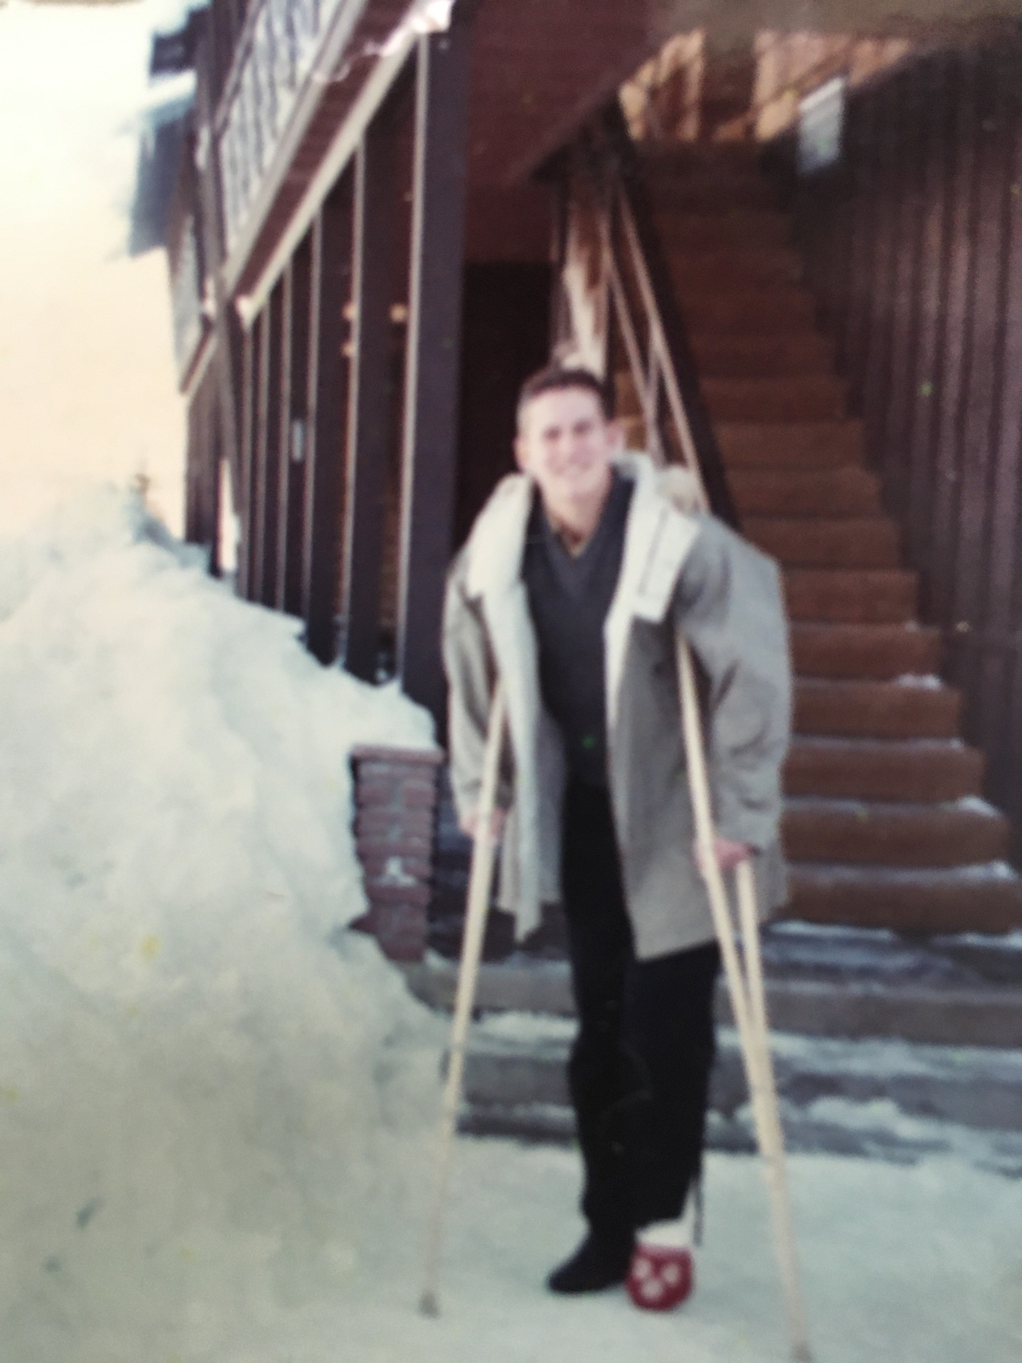Outside The Blue Spruce Inn. Aspen, 1962
© Copyright 2021. Property of Robert Ogden. If copying, please attribute to author.

