Chapter 9 - High School Days
Breaking my leg turned out to be a good thing for me socially. I was 14 years old, and like most kids that age, eager to be accepted by other kids, especially those of the opposite sex. When I showed up at school after our winter break with a full leg cast and crutches, everyone wanted to know what happened. The story was pretty cool, and I’m sure it soon made the rounds, especially since it involved skiing, something that probably none of the other kids in my school had ever done. It seemed that everyone in my grade, both boys and girls, wanted to sign my cast. It was wonderful being the center of attention, answering all kinds of questions: “So how did it happen?” “Did it hurt a lot?” “How long will you have to have the cast?” I honestly think that all this attention gave me the self-confidence to befriend everyone, and I soon became quite popular. That year, ninth grade, I was elected class secretary, and the following year I was elected class president. Class offices — popularity contests if there ever were any!
A lot of people look back on their high school years as a time of apprehension and insecurity. Not me, I loved my high school years. It seemed that everything went well for me. I was a good student, I played on several teams, I was a class or student council officer every year, and I got along well with just about everyone. It was a blast! It didn’t hurt that the school was small by most U.S. high school standards — there were between 100 and 130 students in each grade, so it was easy to get to know almost all the other kids and to participate in all the activities that one wanted.
Of course, there were cliques, not such a wonderful aspect of high school. In our school those cliques took the form of fraternities and sororities. When I was in ninth grade I was asked to join one of these so-called fraternities; its name was “The Bugs,” and they could easily be identified by their distinctive black jackets with the capital letters BUGS sewn across the back along with a Jiminy Cricket patch. The Bugs were the coolest kids in the school, much cooler (according to us) than the “Cavaliers,” the “Delta Phis,” or the “Gammas.” Tommy Mount was the first kid in our grade to be inducted into the group, undoubtedly because his older brother, John, a senior, was a Bug, and he was the epitome of cool. So Tommy recruited his friends in our grade, and soon we had a cadre of eight or ten freshmen in our fraternity. Tommy, Rick Cromwell, Mike Norris, Bill Birkenmeier, Jim Stanton, Tom Kandell, Jon Church, Richie Ainslie — these guys were my “brothers.” But I also had some really good friends that weren’t in our fraternity: Grant Brandon, Skip Green, Jerry Newgord, Henry Garcia, and lots of other guys that I knew from the teams I played on and my other school activities.
In addition to socializing, I should mention that, odd as it may seem, we also attended classes in high school. We had some wonderful, and a few very eccentric, teachers. I could write long description about some of them, but I’ll limit myself to a few recollections of some of the most memorable ones.
Mr. Weatherbee was my ninth and tenth grade English and Creative Writing teacher. He taught us, to the best of his ability, to be descriptive yet concise. (How am I doing?) And who could forget how he sat in the lotus position on his desk as he asked us to ponder a given passage from Hemingway or Steinbeck?
His wife, Mrs. Weatherbee, was my junior year trigonometry teacher, junior year physics teacher, senior year calculus teacher, and senior year physics-II teacher. I saw a lot of Mrs. Weatherbee, twice a day for my last two years of high school, and I just wish she had been half as good a teacher as her husband.
Mr. Rodríguez, who taught us biology, was a traditional Mexican teacher whose methodology consisted of reading his 25-year old lectures to us, which we copied verbatim into our notebooks. He would periodically review our notebooks for accuracy, and then test us on their contents. Rote learning at its best. He also gave us daily oral quizzes based on the previous day’s lecture. This is how it worked: He’d say something like, “Miss Niven, give me a number between 1 and 10.” If Miss Niven said “2,” then Mr. Rodríguez would count down two names from her name on his class list, and that person would have to answer his next question. “One. Two. Mr. Ogden! Can you tell us, please, what distinguishes the mammals of the order chiroptera from other mammals?” Oh Lord, why didn’t I look over my notes?
Undoubtedly the most valuable class I took was, ironically, an elective: typing — “keyboarding” in modern parlance — taught by Mrs. Jeffries. I was one of the few boys in the class, and I was only there because my father insisted that I take the course. At the time I did not appreciate how useful this skill would prove to be, not only in college but for the rest of my life. The typewriters were monstrous devices complete with the warning bells that told you that you were a few keystrokes from the end of the line of type and therefore it was time to “throw” the carriage to the next line. All the keys were covered, forcing you to memorize each key’s location by touch. And you had to exert just the right amount of pressure on the keys, lest the resulting printed letters be either too light or smudged. The business letters, “friendly” letters, and other kinds of documents that we had to type were graded not only on our typing speed, but also on the number of errors and the quality of the print. I was pretty good, and perhaps could have aspired to become a secretary except that I dropped the sequel — shorthand. Dad thought shorthand would be really useful, too, for taking lecture notes in college, but I never got the hang of it. As I recall, I got a study hall in its place, the only study hall I had in all my high school years. What a luxury that was!
Mrs. Hunter, our eleventh grade English teacher, made us memorize famous passages from Shakespeare (which, unfortunately, I’ve long since forgotten), and she could, herself, recite impossibly long passages. And not only did she recite them, she emoted! Wow, tears would come to her eyes as she re-enacted Cleopatra or Lady Macbeth!
Madame Dauchat was an elderly French lady who, in addition to teaching French, also taught German. Dad thought that German would prove the more useful of the two languages, so that’s what I took, for two dreadful years. Was he ever wrong in his choice of language for me! Many years later I decided to learn French, and it might have been an easier task if I had had some background in high school. Suffice it to say that German is impossibly difficult, and I have basically nothing to show for my two years of study.
Of course I still have a lot more to say about my high school years — my girlfriends, a few pranks, a fight, and several amazing adventures — but I will make them the subjects of separate chapters.

© Copyright 2021. Property of Robert Ogden. If copying, please attribute to author.

Chapter 10 - High School Sweethearts
In tenth grade I fell in love. Nancy Clark was not as exotic as Zia Shields or as beautiful as Jenny Bano, but she was the one for me, and we both knew it was the real deal. When circumstances tore us apart a year later and I was heartbroken, I remember my mother consoling me by saying that, in spite of how people often belittle young love, it can be just as strong as that between older, more mature people. “Don’t let anyone tell you that the love you feel at age 15 or 16 can’t be true love. I know that it can.” I’m pretty sure Mom was speaking from experience.
Nancy didn’t go to our school; instead she went to Lomas High School, which might have been an alternative for parents who thought the American School was too much like a country club. (Where would they have gotten that idea?) One day she and a friend of hers, Donna Koske, happened to go to a baseball game that I was playing in, and she was probably there to cheer on her school’s team, the team we were playing against. As she sat on that team’s bench I could hardly keep my eyes off her — her long blonde hair, her slim figure, the way she held her head up, her erect posture. Very classy. I was hopeful that she was watching me, too, but I figured that in all likelihood she was interested in one of the boys on the other team. At that point I didn’t even know her name.
Nancy and I did not meet or speak that day, but somehow Donna got us together a few days later. I wish I knew the details of how that happened, but I believe that Donna arranged a blind date, and that was the beginning of our romance.
Nancy was a year older than I, and in 11th grade. She liked to joke that she preferred younger men because that way she could “mold their character.” I thought that was pretty funny, but as a matter of fact she did have a big influence on me. For example, she was an “A” student, and I was sure that a smart girl like her would not be interested in any dummy, so that was an incentive for me to do well in school and keep my grades up. She also loved Mexican music, and so I became interested in Mexican music. I admired her self-confidence, her poise, and her intelligence, and I didn’t want to disappoint her by not living up to her high standards. So perhaps she did, in fact, mold my character.
Our romance did not end with a fight or because of another person; it ended because her father, who was an attaché at the Canadian embassy, was transferred to the consulate in Los Angeles. She would miss her senior year in Mexico, spending it instead at a school in L.A. We were both devastated, but at our age this travesty was completely out of our control to change. We stayed in touch with frequent letters and occasional phone calls, but phone calls were an expensive proposition in 1963 and ‘64. My allowance hardly allowed for a five-minute call. Regular in-state long-distance calls in the States were expensive, out-of-state calls were even more so, but international calls were prohibitive, so calling often was not an option for Nancy and me.
Try as we might to keep it alive, distance ultimately doomed our love affair, and by the middle of 11th grade I was ready to try a relationship with someone else. It would be a long time, though, before I found anyone I loved as much as I loved Nancy Clark.
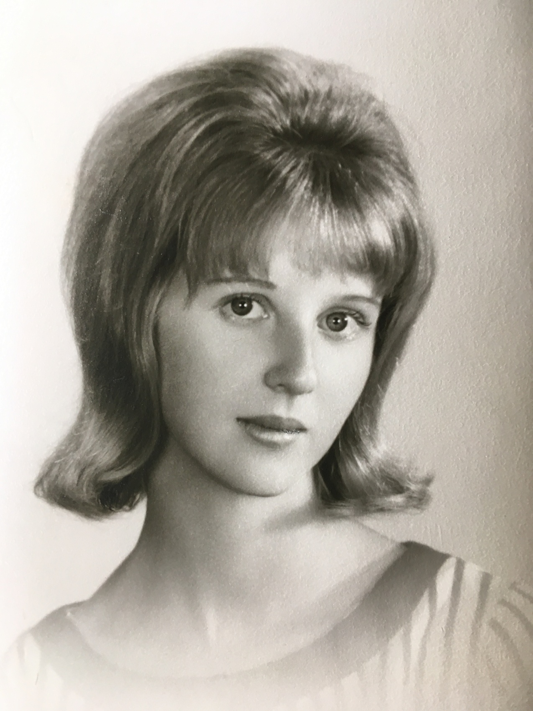Nancy Clark, my first love. 1964
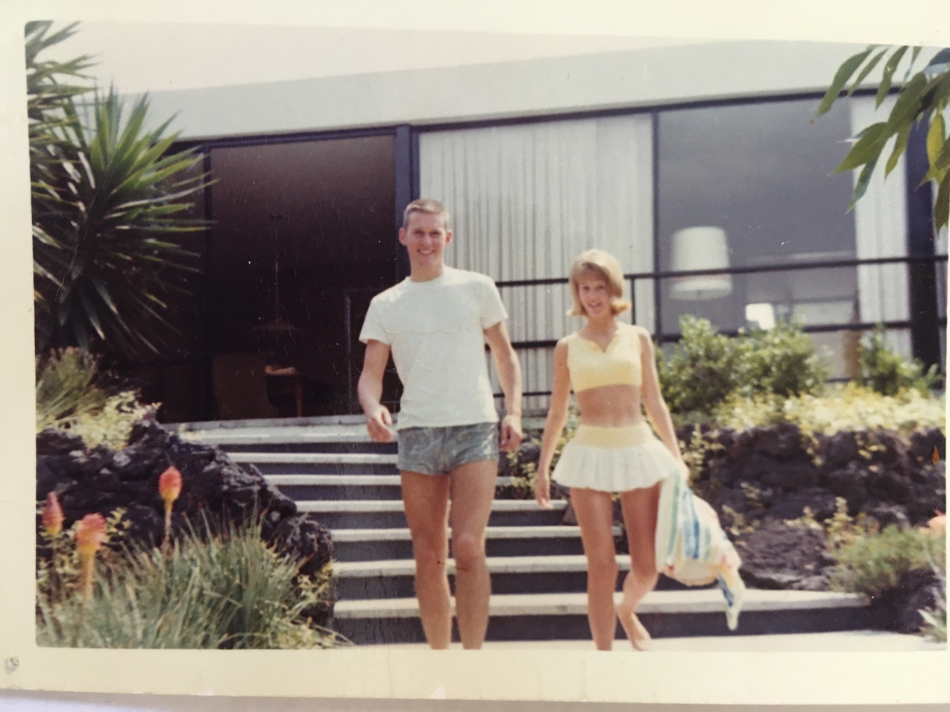
Nancy and me at our house in Pedregal. 1964
For a while I was interested in a girl by the name of Ellen Wichtrich. She was a year younger than I, tall and very pretty with lots of freckles and long red hair. For her birthday that year I convinced my friend Jerry Newgord to accompany me to Garibaldi Square, where the mariachis hang out, and I hired a group of six or seven musicians to go to Ellen’s house for a traditional Mexican serenade. Sometime around midnight the mariachis and I awoke her, and her entire family, too, with my rousing renditions of “Las Mañanitas” and a few other romantic songs, while Jerry stood in the background laughing his head off.
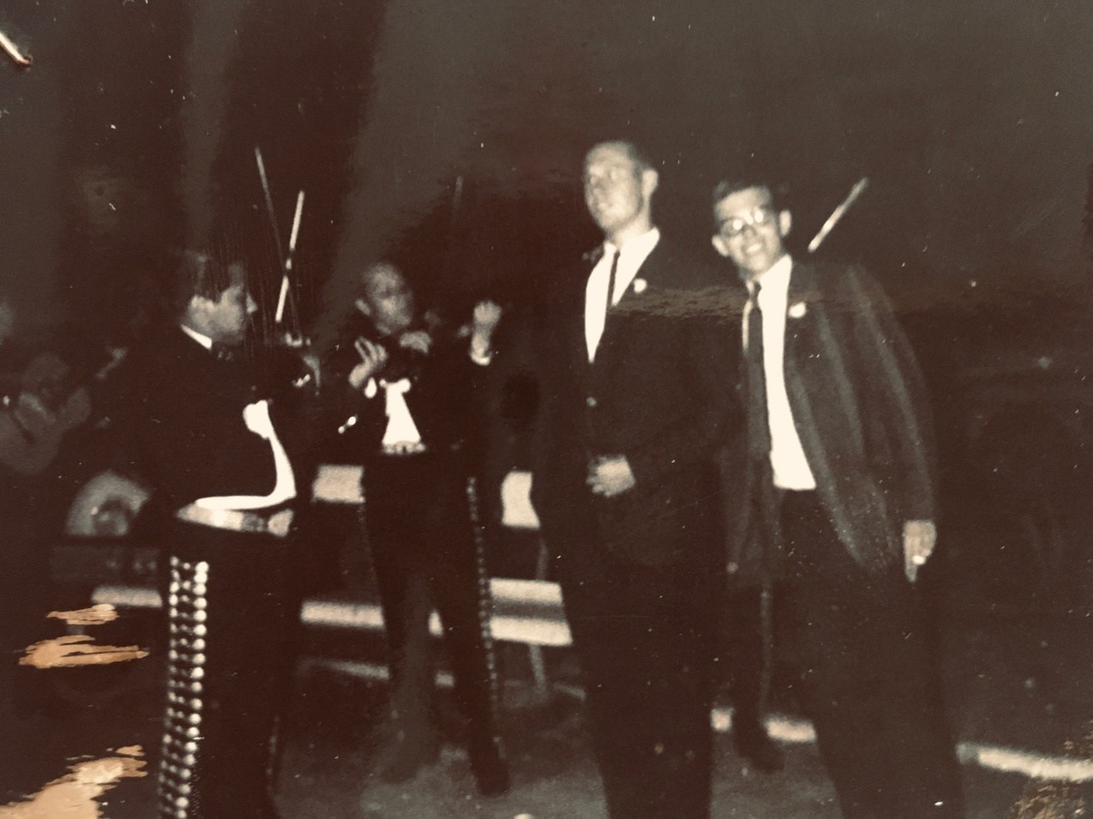
Jerry and me at Garibaldi Square, rehearsing with the mariachis.

In spite of the serenade, I was never serious about Ellen, and before long she and I broke up. Soon after that, a very sexy girl in my class, Noel Webb, caught my eye. I asked her out, and we had a great time together, but after the first time I kissed her good night she confessed to me that she was Danny Dollarhide’s girl. What?! Danny Dollarhide didn’t even go our school anymore, and he hadn’t since ninth grade! He was off at prep school somewhere, and only came home for school vacations! Nevertheless, she said that she and Danny were true to each other. Well, I couldn’t believe that I couldn’t steal her away from someone who wasn’t even there, and since she was happy to go out with me, I was determined to do just that. How long did I live with the illusion that I was winning her over? Probably until Christmas break, when Danny came home, and Noel, true to her word, chose him over me. So that was the end of my fling with the lovely Noel Webb.
There were only six more months before graduation, and I don’t remember going out with anyone in high school after Noel, but I did need a date for the senior prom. I had no idea whom to ask, and back then a girl wouldn’t think of asking a boy. I wound up going on a blind date with a girl by the name of Debbie Zambianco, and I have practically no memories of her or of that night. Obviously Debbie did not make much of an impression on me. But she certainly did make an impression fifteen years later at our first high school class reunion in Austin, Texas. I’m getting ahead of myself chronologically, but this is what happened. A group of us guys were standing around reminiscing about the good old days, when an attractive woman joined the group and said to me, “You’re Bob Ogden, aren’t you!”
“Why, yes, I am. But I’m sorry, I don’t recognize you.”
“It’s Debbie!”
“Debbie?” I was confused, as I still did not recognize her. “I’m sorry, but I still can’t place you.”
“Debbie! Debbie Zambianco!” When I still had a blank look on my face, she blurted out, “We went to the senior prom together! Don’t you remember that either?”
She might have added, “You idiot,” before she walked away.

© Copyright 2021. Property of Robert Ogden. If copying, please attribute to author.

Chapter 11 - The Maximilian Trail
When I was in the ninth grade a had a motorscooter (a Moto Islo), and by tenth grade I was preparing to get my regular driver’s license. This meant driving the family cars — a 1958 two-tone green Dodge Coronet with push button transmission controls and an Oldsmobile-88 of about the same vintage. For a while, Mom or Dad would accompany me as I drove around the streets of Pedregal where there was seldom much traffic, and once I got the hang of it they would let me drive alone. What a mistake that was! One of my favorite things to do when I was accorded such freedom was to stop by at Grant Brandon’s house, and he and I would go for joy-rides, mostly in the Dodge.


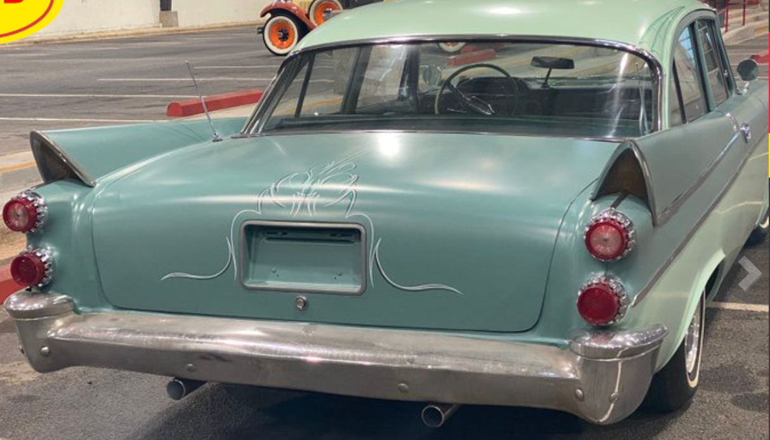
1958 two-tone green Dodge Coronet

Our favorite such ride would start at the top of a street by the name of Fuego, and from there it was a steep downhill run for a good mile and a half — a mile and a half of adrenalin-induced speeding. I remember glancing down to see the speedometer go past 100 k.p.h., much too fast for a residential neighborhood. Grant remembers scattering chickens in our wake. (chickens? on the streets of Pedregal?) All I remember is his asking me to slow down. I knew that I should, but I just couldn’t do it. I wanted to see how fast I could get the Dodge to go without … without what, killing someone? killing ourselves? I’ve heard that the male brain is not fully developed until about the age of 30. What is its development at fifteen?
As part of my learning to drive and being responsible with a car, Dad taught me how to park the two cars in our garage, which was down a short steep hill and under our house. I had to open our wooden gate and carefully ease the cars into their places. That was my responsibility every night before I went to bed.
One fine Saturday, my friends Tom Mount and Rick Cromwell came to spend the afternoon with me and stay overnight. We were up pretty late, just shooting the breeze and listening to our music. At around 10 p.m., Dad came into my room and said that he and Mom were retiring for the evening and that I shouldn’t forget to put the Dodge in the garage before going to bed. “Sure, no problem, Dad,” said the responsible son. So at about 11:00 I asked my friends if they would like to go for a little spin around the neighborhood before putting the car away, and, like any normal 15-year-olds, they thought that would be fun. But first, knowing that we might be gone for a while, and just in case Mom or Dad came into my room to check on us, we put our pillows under our blankets to make it look as if one of us were asleep in my bed and the other two were asleep on the floor. No one can accuse me of not taking precautions.
We cruised around for a while, but that soon got a little tiresome, so at some point Tom said, “Hey, why don’t we go check out the Maximilian Trail?” Without getting into too much historical detail, suffice it to say that Maximilian was an Austrian archduke who reigned as the Emperor of Mexico from 1864 until his execution in 1867. He and his wife Carlota lived in Chapultepec Castle, and they had a country estate in Cuernavaca which they would occasionally visit to enjoy that city’s mild, sub-tropical climate. The cobblestone road leading to Cuernavaca was called “El Camino de Maximiliano,” or “The Maximilian Trail,” and it passed near the Pedregal, not far from our house. We had heard about this trail, but none of us had ever actually been on it. Tommy had a vague idea where it was, so we set out to find it.
We found the trail as it crossed a newly paved street. I pulled onto it, and we bumped along the ancient cobblestones for about a half-mile, until that, too, got to be routine and we decided to head back. I couldn’t find a good place to turn around, so I simply tried to do a three-point turn. While backing up, I suddenly heard a loud thud; my rear wheels had gone over the edge of the cobblestones to … a void! The car’s chassis was resting on the cobblestones and the wheels were spinning in the air. “Okay, guys, time to give it a push!” I said. Tom and Rick got out while I gunned it, but the car didn’t budge as the wheels did nothing but spin. “We need to get something under the wheels!” said Rick. Right, but what? We looked around for something, but there was nothing but lava rock and brush. “I saw a construction site just before we turned onto the trail,” said Tom, “maybe we can find a board or something there.” My friends had lots of good ideas. So we headed back to the street, walking this time, and sure enough, there was a house being built and lots of construction materials lying around, carefully supervised by a sleeping night watchman. “Look! A ladder!” whispered Tom. “Let’s borrow it!” So we grabbed the ladder and headed back to the car. By then it was about midnight.
We pried the ladder under one of the rear wheels, but no luck. All the car’s rear weight was resting on the cobblestones, and putting a ladder under the wheels was not going to change that. So now what?
We walked back to the house, which must have taken another half hour. We quietly rolled my Moto Islo out of the garage, and, once safely out on the street, started it up. The busy neighborhood of San Angel was about a ten-minute ride away, so we thought that we could find a garage with a tow-truck that could get us out of this predicament, preferably before dawn. But of course, no garages were open at 2:00 a.m., and we knew we were in for it. We’d just have to awaken Mom and Dad and confess.
As we were cruising back to the house, up Calle Cráter, to our horror we saw the Oldsmobile pull up to a stop at Cráter and Risco! Oh God, Mom and Dad were out looking for us! I pulled the scooter over to the side of the street, and they pulled alongside. Dad very calmly said, “Meet us at the house.” That was a very tense five-minute ride back home.
I don’t think I had ever seen my father so angry with me as he was then. He came flying out of the Olds, and gave me a push against the wooden gate — the same wooden gate that I had neglected to fully close an hour earlier when we took the motor scooter out. As luck would have it, a night watchman (they had such people back then) happened by and saw the gate open. Rather than doing the normal, logical thing, i.e. close it, he rang the bell to inform the homeowners that their gate was open. In doing so he woke up my father, who then noticed that the Dodge was not in the garage. Suspecting that I had done exactly what I did, he and Mom, who by now was also awake, went into my room, only to discover three sleeping “bodies.” How could that be? Someone must have stolen the Dodge! Dad was about to call the cops when, upon closer inspection, Mom realized that those “bodies” were, in fact, pillows. So ours was not just a crime, it was a pre-meditated crime! I’m sure their feelings were a mixture of worry and anger — mostly worry on Mom’s part, anger on Dad’s. They jumped into the Olds and headed off in a frantic search for their son and his friends. Criss-crossing the streets of Pedregal, they just happened to come across a red motor scooter with three boys on it, heading up one of the major streets in the direction of their house. Mom, I imagine, was relieved that we were alive, Dad was just plain furious.
So, as Dad directed his ire at me, Mom, amazingly, blamed Tom! “This is all your fault, Tommy Mount! You’re a bad influence on my son! You stay away from him! Now go home! You, too, Rick whatever-your-name-is!” (Ouch! Tommy lived in San Angel, at least an hour’s walk away.)
Mom’s reaction turned out to be a far worse punishment than Dad’s shove, but not because Tom stayed away from me. How could he, anyway? We saw each other all the time in school. No, her reaction was worse for me because Tom and Rick realized that my mom thought I was an angel and that they were a couple of juvenile delinquents. I’m sure that word spread around school about Ogden’s crazy mother.
The next morning, when the garages were open, Dad called for a tow truck to go out to the Maximilian Trail and look for a green ‘58 Dodge Coronet — which I would be forbidden to drive for quite some time.
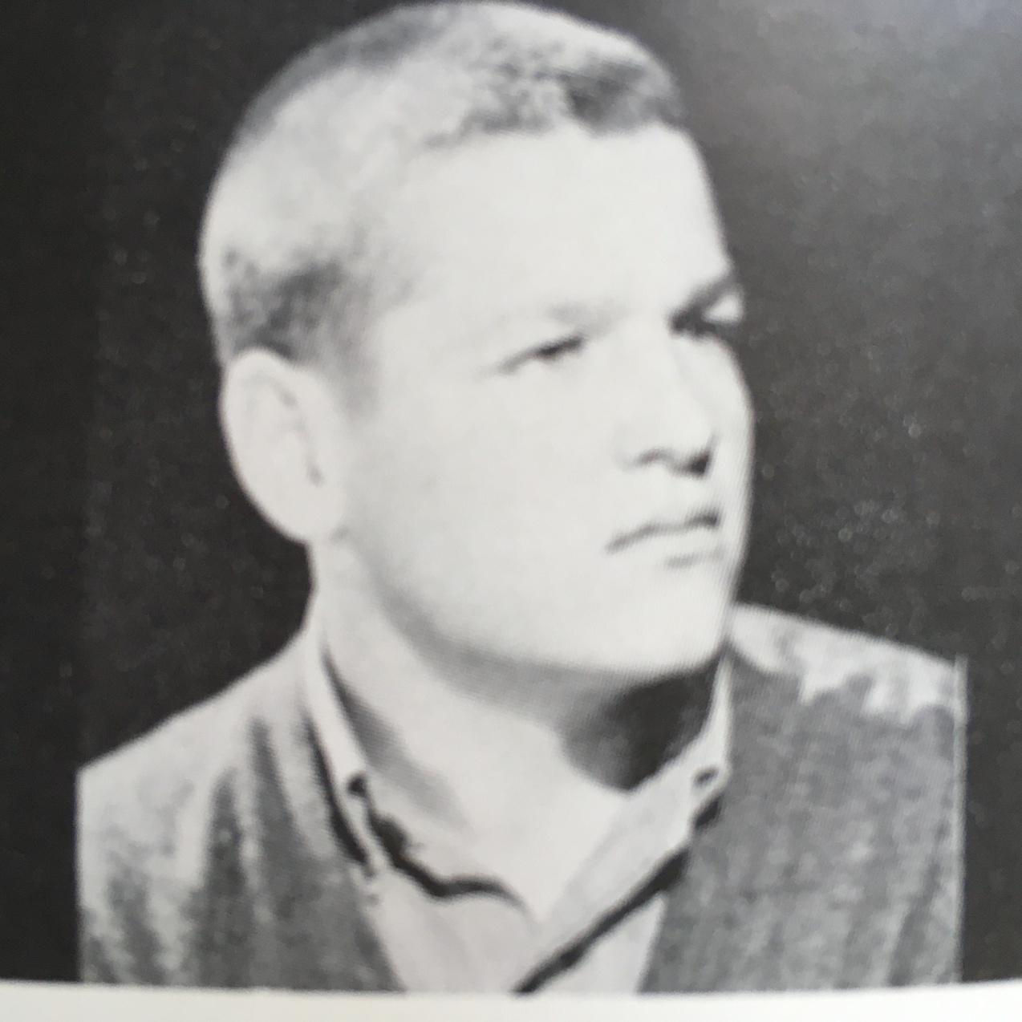
Tom Mount, “a bad influence”
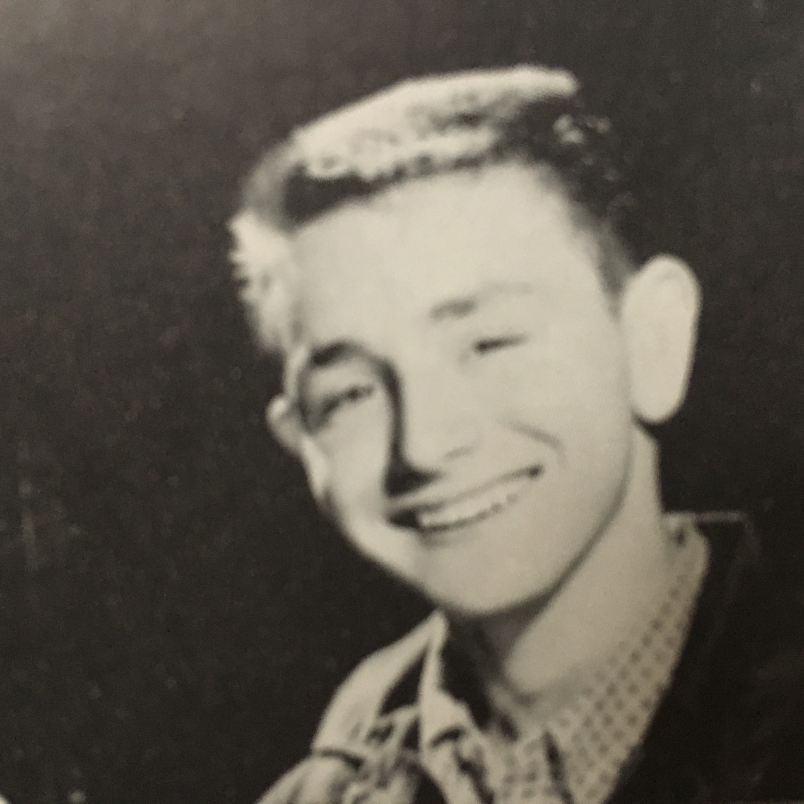
Rick Cromwell, another juvenile delinquent (per my mother)

© Copyright 2021. Property of Robert Ogden. If copying, please attribute to author.

Chapter 12 - Greek Drachmas
When I was in the tenth grade, I had a friend by the name Jon Church who lived in the Pedregal not far from my house. Jon’s father worked for the United Nations, and the family had recently moved to Mexico from his father’s previous assignment in Athens, Greece. Since Jon was one of the few kids my age who went to my school and who lived in the Pedregal, he and I got together on weekends fairly often, mostly to go to San Angel and shoot pool at the local pool hall. Jon and I were about evenly matched when it came to pool, which is to say, pretty lousy. But we enjoyed it. Minnesota Fats wannabes.
One day, when I was at Jon’s house, he said he wanted to show me something. From his closet he pulled out a shoebox which he set on the bed. When he opened it I saw that it was filled with money! Bills of some sort that I had never seen before, with funny letters on them. He told me that when he lived in Greece, his father used to play poker with his buddies, and instead of using chips they used pre-war drachmas. I had no idea what pre-war drachmas were, so he explained that “drachma” was the name of Greece’s currency, and that in the years leading up to World War II there was runaway inflation in the country such that, when the war was over, the Greek government decided to do away with the old drachma, with its bills in denominations of 1,000’s, 2,000’s, and 10,000’s, in favor of a new currency with three fewer zeroes. Henceforth, the currency would be called “new drachmas.” Anyway, he just wanted to show me this amazing stash of bills which made it look like he was some kind of millionaire. Pretty cool, right? Well, yes, except that the old drachmas were discontinued and no one accepted them anymore.
Ah, but I had an idea! “Jon, nobody in Mexico knows that this stuff is worthless. And it looks like real money! It WAS real money! Let’s take it downtown to a “casa de cambio” (where one had to go to exchange money in those days) and see if we can exchange it for pesos! I wonder what it would be worth?” I was so excited I could hardly stand it.
Jon thought I was crazy. “No one is going to give you real money for this, you idiot, ” he said.
“Well, let’s just go and find out,” I replied.
I thought we should take the whole shoebox full, but Jon didn’t want to take any at all, arguing that the entire idea was preposterous. We compromised, agreeing to take a small amount. I told myself that, if this worked, as I thought it would, we could always go back again. So, after putting a couple of wads in our pockets, we took a series buses and “peseros” all the way downtown. Downtown was not a place that we frequented very often — it had a fair amount of crime, and besides, we never had any particular reason to go there. Until now.
Once downtown, we entered the first exchange house we saw and explained to the attendant that we were Greek tourists, and that we needed to exchange our money for pesos. I’m sure she didn’t know a Greek from a Swede from a Chinaman, but that didn’t seem to make any difference because she told us that they didn’t deal with any currencies other than American, Canadian, British, French, and a couple of others. Oh well, thanks anyway. Undaunted, we tried another place, with the same story, but this time the guy got out a sheet of paper which had the various countries’ currencies listed, and on it was Greece’s! Bingo! We showed him the bills we had, he did some math, and then he handed us 525 pesos (US$42 at the time). This was a fortune in 1962! We had never had that much money before! It was all we could do to stifle our glee at this amazing bonanza.
Flush with cash, we casually exited the casa de cambio and ambled down the street until we got to the nearest corner, at which point we took off at a dash. “They’re going to find out, and then we’re going to be in big trouble,” Jon said. “No, I don’t think so,” I replied. Well, I was right; no one came after us. We made it back home without incident, much richer than when we left.
Greed reared its ugly head, and the next weekend we decided that we’d try it again, but this time with a lot more than 525 pesos worth of drachmas. We stuffed our pockets with the phony cash, and headed back downtown, avoiding, of course, the casa de cambio where we’d made our first transaction. Something was different this time, though. We tried about eight exchange houses, but not a single one would accept our money. Evidently in that one week every Mexico City casa de cambio had heard about the phony Greek drachmas. What’s surprising is that we weren’t identified and arrested. Oh well, at least we got 525 pesos out of the deal. “I told you, Jon, we should have exchanged more money the first time! Too late now, you moron.”
Disappointed, we decided that, since we were already downtown, we might as well shoot some pool. So we found a pool hall, got a table, and proceeded to play our first game. As we were setting up the rack for a second game, a guy approached us and asked if we could teach him how to play this interesting-looking game. He said he had just come in from a remote village, and he was eager to learn some of the many diversions of the city. So we patiently explained to him the basics of pool — about the cue stick, about hitting the white ball with it and getting the numbered balls to fall into the pockets, and so on. He was a slow learner, holding the cue stick in an odd way, for instance, but we were patient teachers, and we helped him with his form.
He said, “This is fun! Let’s play a game.” So we played a game with him, and he was pathetic. But he was such a nice guy, eager to learn and to improve, and it was fun showing off our skills.
After we clobbered him in the first game, he said he wanted to play another one. “Well, we really need to get going, but maybe one more,” we said. “For the fun of it,” he replied, “let’s put some money on it,” at which point he showed us a wad of pesos that he had in his pocket. “I sold my pigs before coming to the city, so I’m feeling kind of rich. And this is a lot of fun. Let’s bet a couple of hundred pesos on the next game.” Jon and I looked at each other, and we thought, “Hey, another lucky day!” So we agreed.
Well, the country hick who didn’t know how to hold a cue stick was a very fast learner. He began dropping balls into the pockets like we had never seen it done before. Before we had a chance to catch our breath, the game was over and we owed him 200 pesos. We did not have 200 pesos. It finally dawned on our 16-year-old brains that we’d been hustled. So now what? I explained to the guy, as calmly as I could, that we were Greek tourists, and that we hadn’t changed much money yet, but if he would accept these Greek drachmas, they should be worth about 200 pesos. He agreed, we “paid” him, and we quickly left and caught the first “pesero” back to Pedregal.
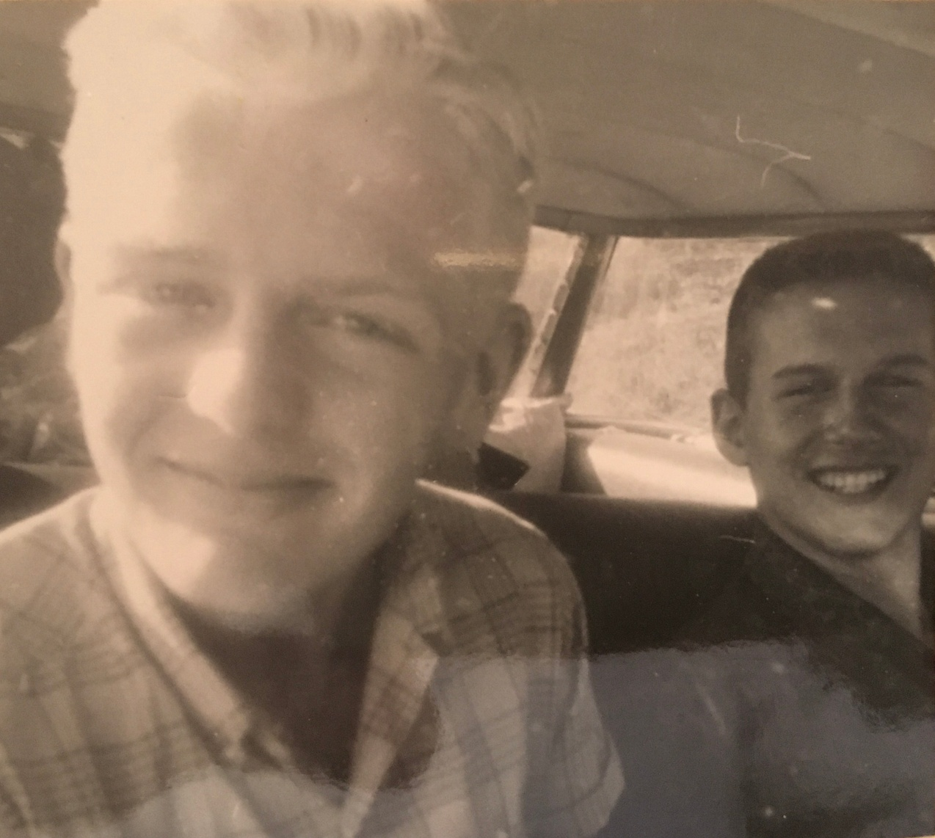Jon Church, yet another juvenile delinquent

© Copyright 2021. Property of Robert Ogden. If copying, please attribute to author.

