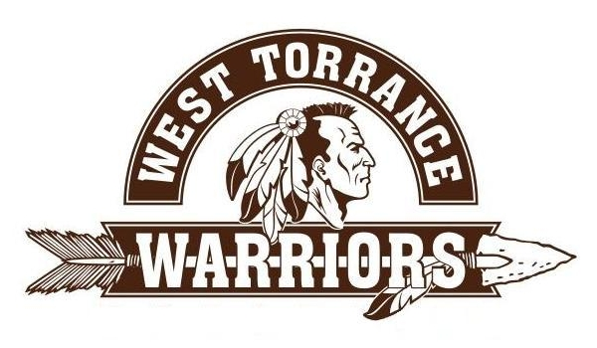

WEST HIGH SCHOOL REUNION DINNER & DANCE
CLASS OF 1981

Please join us to celebrate our 35th year Reunion!

DATE: SATURDAY, AUGUST 6, 2016
TIME: 5:30 – 11:30PM
LOCATION: THE DOUBLETREE HOTEL Phone: 310-540-0500
21333 Hawthorne Blvd, Torrance CA 90503
We will be having a DJ and a fun photo booth.

COST: $85 PER PERSON BY April 30, 2016 or $100 PER PERSON AFTER April 30, 2016.
Limited seating – must RSVP by July 1, 2016. Your cancelled check will be your receipt.
Casual dress or if you like you can dress up.

If you have any questions, please contact: Terri Blevins Lewis #310-350-7089 or Valerie Velez Hilzendeger #310-218-8271 or email us at WHSclassof1981reunion@yahoo.com.

- - - - - - RSVP deadline July 1, 2016 - return lower portion - - - - - -
Please Print

Name(s)______________________________________________________________

Address______________________________________________________________

Telephone______________________________Email__________________________

Maiden name if applicable___________________________

Number attending by February 1, 2016 ____ @ $85 = Total $______________

Number attending after February 1, 2016 ____ @ $100 = Total $____________

Credit Card #________________________ Exp date______________ CVV Code #_________

MAKE CHECKS PAYABLE TO: WHS Class 1981

MAIL TO: Valerie Hilzendeger at 4705 Sepulveda Blvd, Torrance CA 90505

