Murphy Ranch Book Exchange!
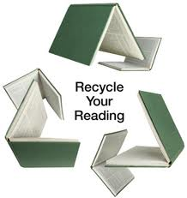

Start cleaning out your bookshelves! It’s time for Murphy Ranch’s first book exchange. The book exchange is a great way for students to share books they’ve finished reading, and get books that are new to them. Students may bring up to 5 books that they are finished with, and exchange those books for tickets. We will organize the books according to reading levels, and then the students can bring back their tickets and get up to 5 books that are new to them! At the end of the week, any extra books will be either distributed to classrooms or donated.
Bring in books to exchange for tickets. We will be set up in front of the office on Mon. Nov. 3rd and Tues. Nov. 4th- 7:45am-8:20am, and 2:30-3:30pm (Mon) and 1:30-2:30pm on (Tues).
Then come back to exchange your tickets for new to you books: Thurs. Nov. 6th and Fri. Nov. 7th- 7:45-8:20am and 2:30-3:30pm.
Books must be in English, and in good condition. We won’t accept any books that are damaged, torn, marked up, dirty, or in bad shape. No board books or baby books please! You are welcome to donate as many gently used books as you like, however you are limited to receive a maximum of 5 books that are new to you in exchange.
It’s a great way to recycle old books, and get new books to enjoy!
Questions? Comments? Please email us at themurphyranchpta@gmail.com

