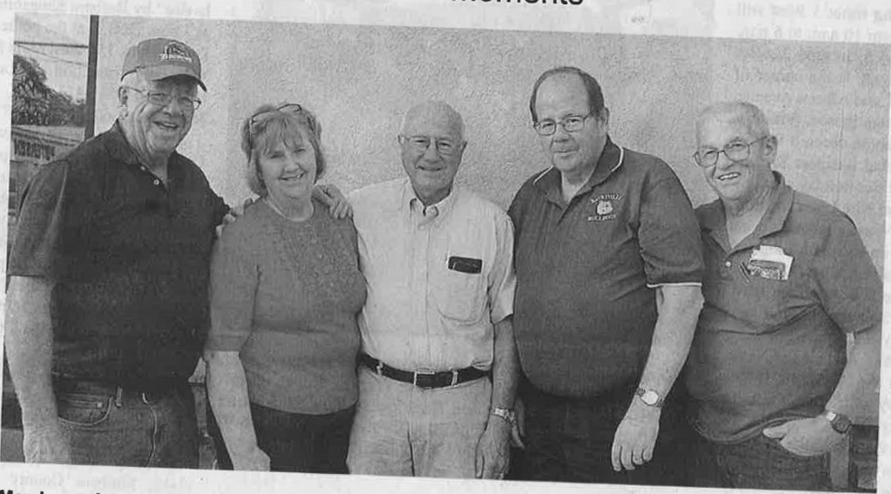

Generosity is all in the family for Vale Alumni.

The Buxton siblings grew up together attended Vale High School and have now joined together by becoming lifetime members of the Vale High School Alumni Association.

Max Buxton, Jolene Reed Buxton, Dwayne Buxton Boyd Buxton, Gary Buxton and Carol Buxton Mick have previously donated money in the past to the association. Gary Buxton recently Made a sizable donation of $55,000.

Alumni president Jim Hutchens recently announced a goal of $1 million for the group to raise. To date, the amount sits over $60,000. Money goes towards scholarships of graduating Vale students.

To learn more about the association, contact Max Buxton at )208) 867-8698 or by email at vhs.alumni@gmx.com.

By John L. Braese
The Enterprise

